Point Symmetry

Definition
# Source: AI Source: Provided by: [Data Path: Persons Table -> ID Column: 1, Name_En Column: Motasem Essam] -> From: [ChatGPT] on [7/25/2026]
Point Symmetry is a type of geometric symmetry in which a figure remains unchanged when every point of the figure is rotated ${180}^{∘}$ about a fixed point.
The fixed point is called the center of symmetry.
In other words, if a figure is rotated through ${180}^{∘}$ around its center of symmetry, the resulting figure coincides exactly with the original figure.
$$\boxed{\text{Point Symmetry}=\text{Rotational Symmetry through }{180}^{∘}}$$
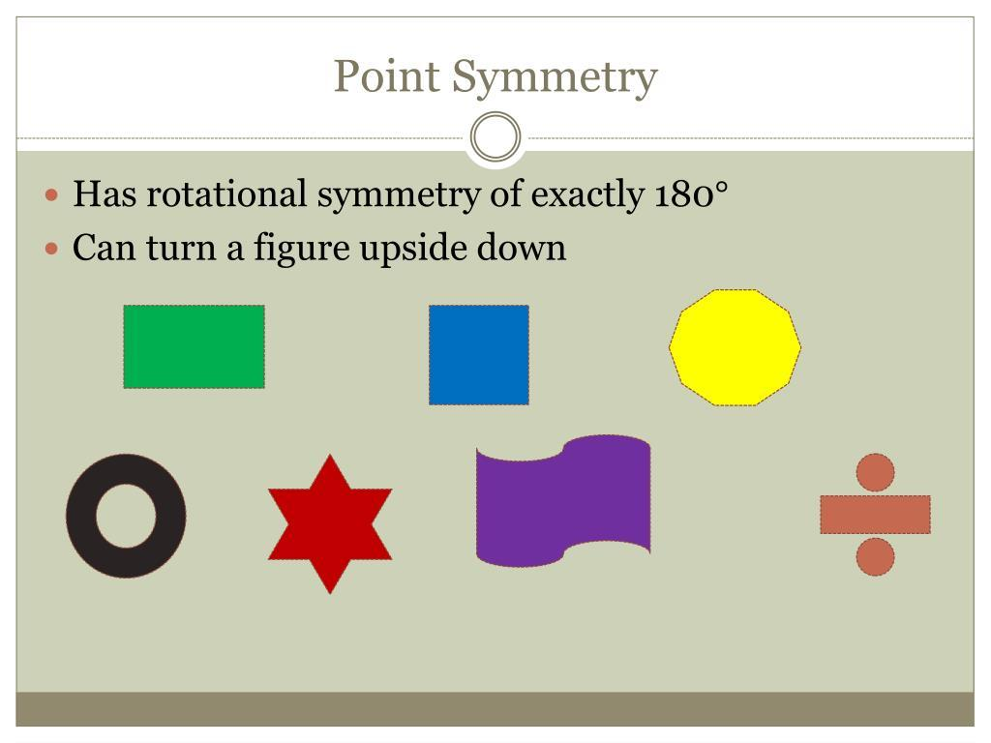
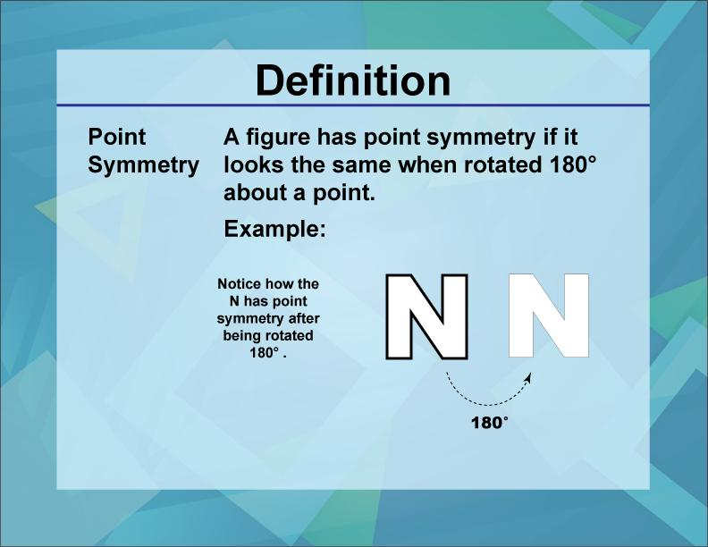
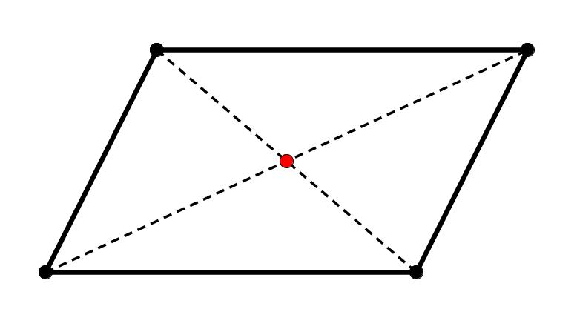
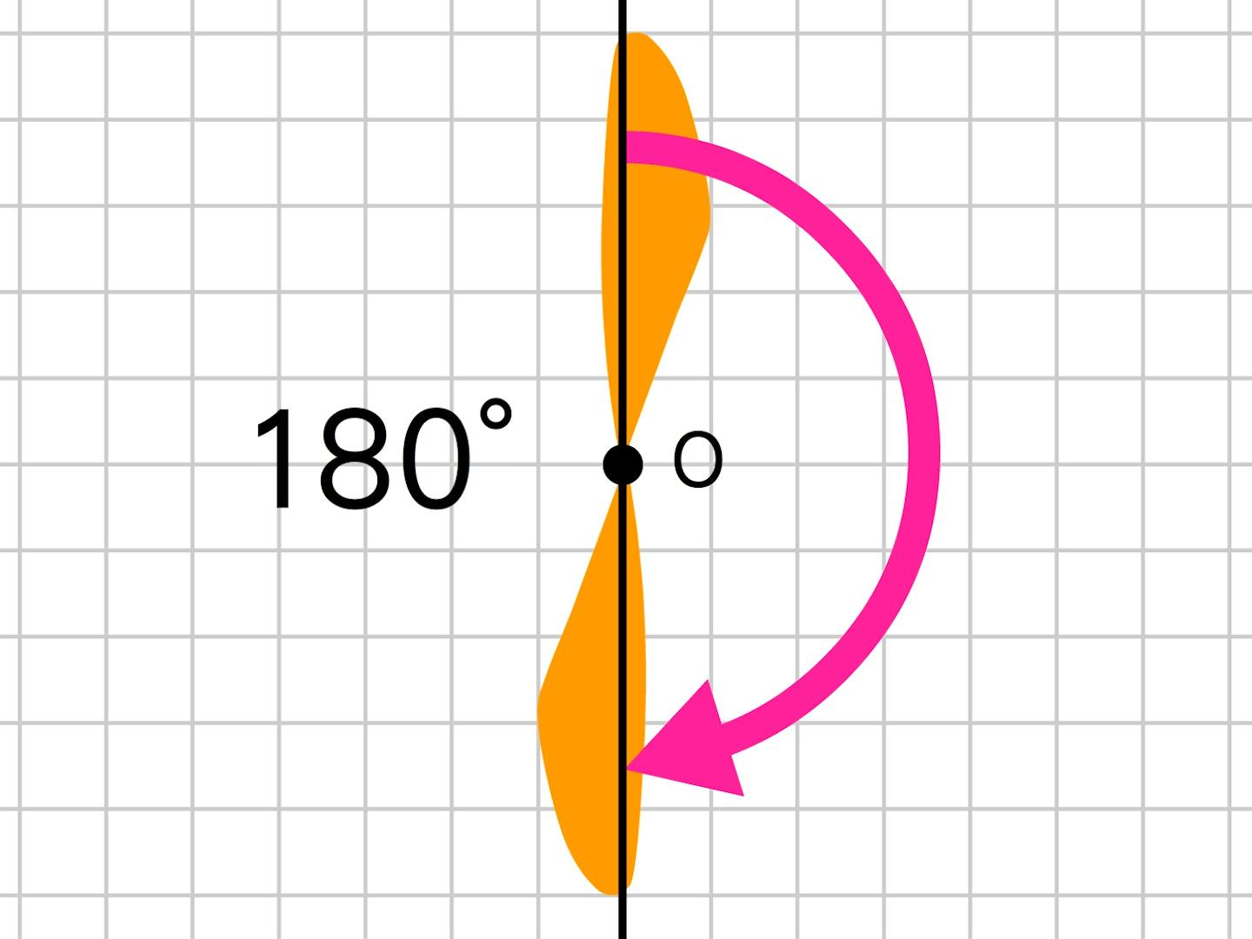
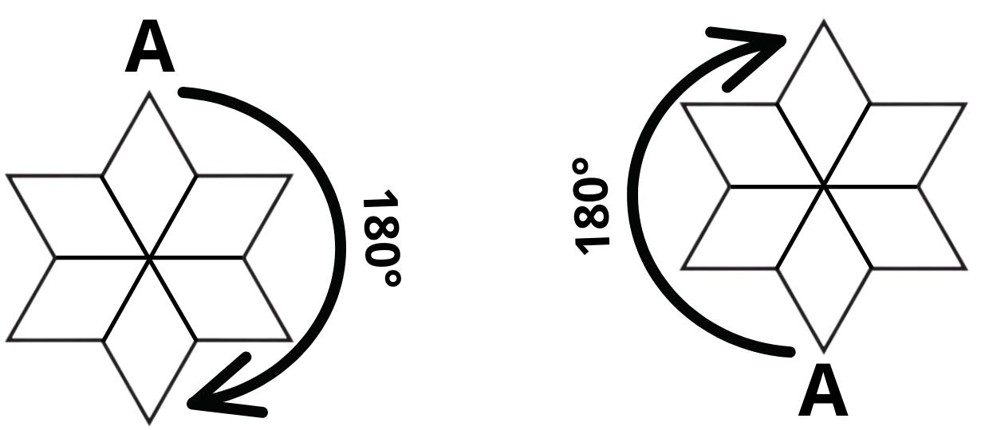
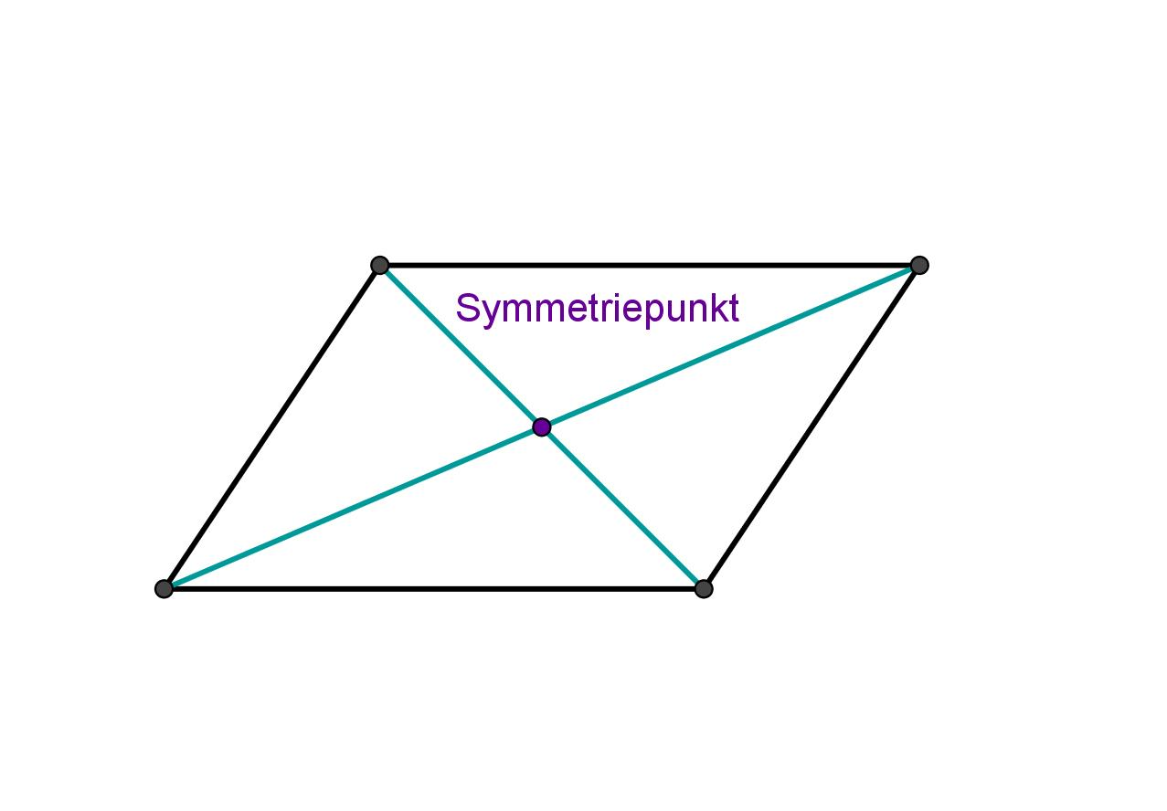

Purpose
# Source: AI Source: Provided by: [Data Path: Persons Table -> ID Column: 1, Name_En Column: Motasem Essam] -> From: [ChatGPT] on [7/25/2026]
Point symmetry is used to:
- Identify figures that remain unchanged after a (180^\circ) rotation.
- Analyze opposite relationships between points.
- Understand rotational transformations.
- Identify centers of symmetry.
- Study geometric figures and their properties.
- Analyze coordinate graphs.
- Create balanced geometric patterns.
- Support architecture, engineering, and computer graphics.

Fundamental Idea
# Source: AI Source: Provided by: [Data Path: Persons Table -> ID Column: 1, Name_En Column: Motasem Essam] -> From: [ChatGPT] on [7/25/2026]
A figure has point symmetry if every point on one side of a center has a corresponding point on the opposite side at the same distance from the center.
If $O$ is the center of symmetry and $A$ corresponds to $A'$, then:
$$\boxed{OA=OA'}$$
and $O$ lies halfway between $A$ and $A'$.
Therefore:
$$\boxed{O\text{ is the midpoint of }\overline{AA'}}$$
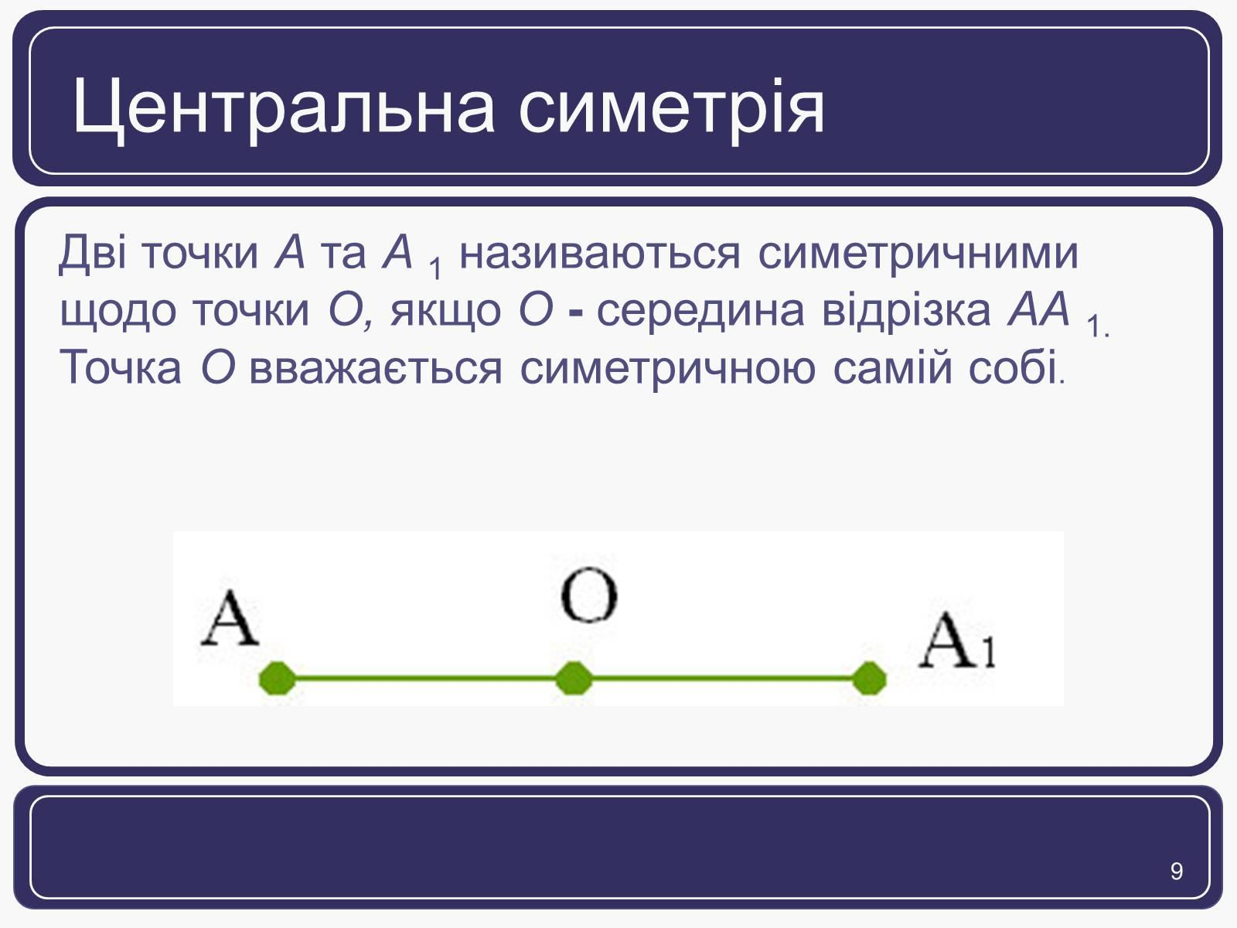
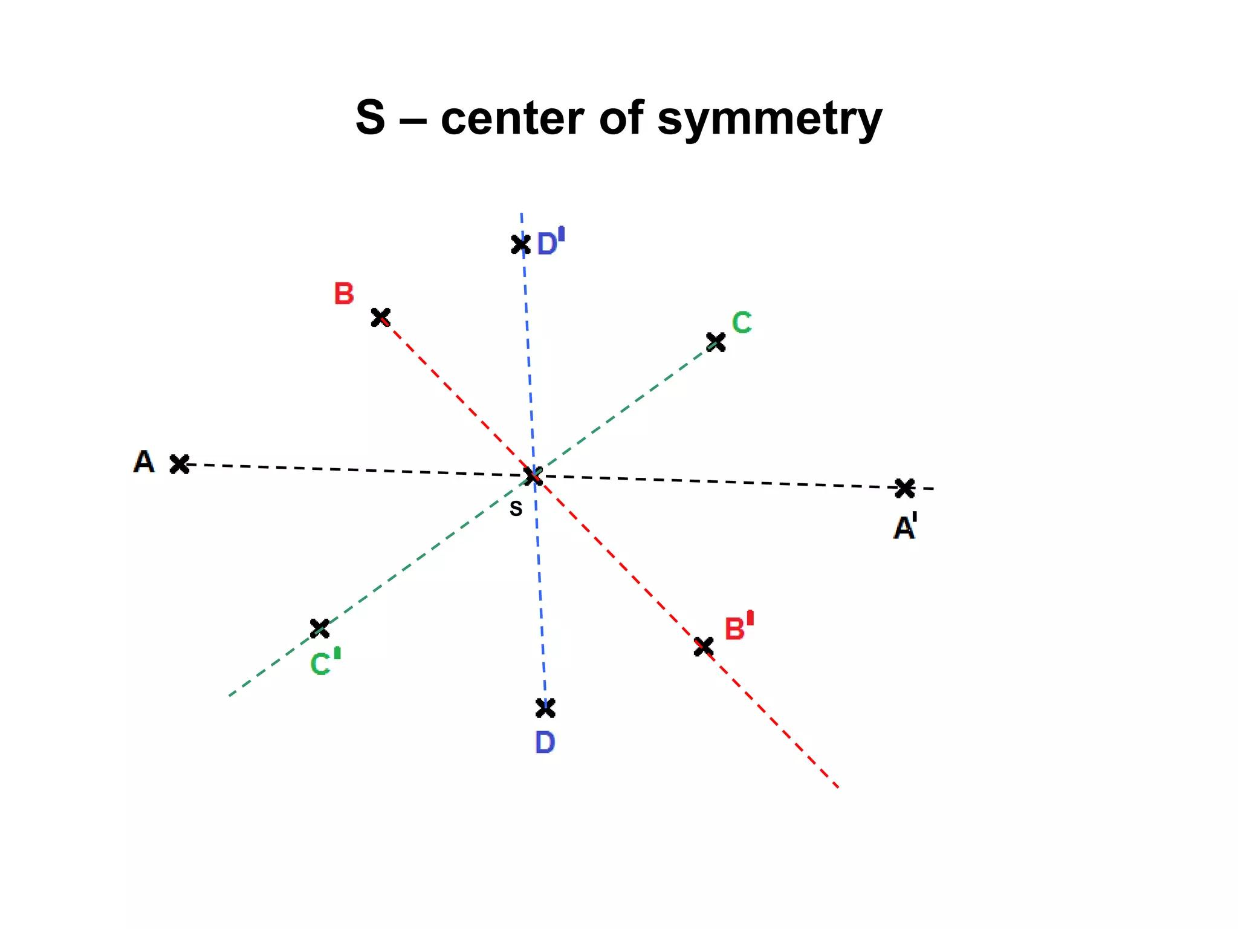
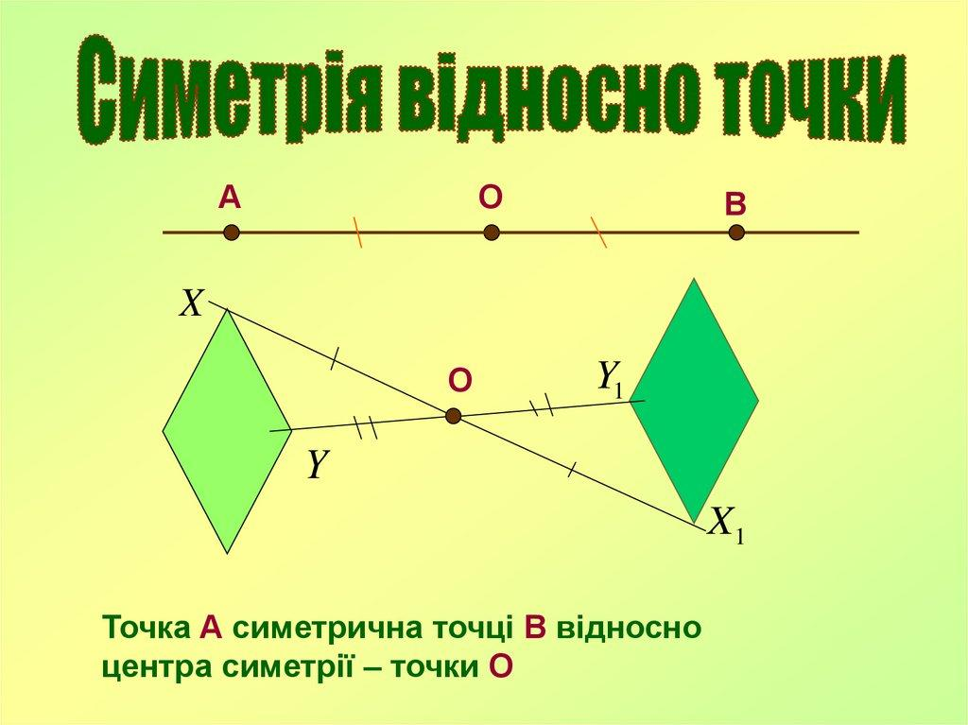
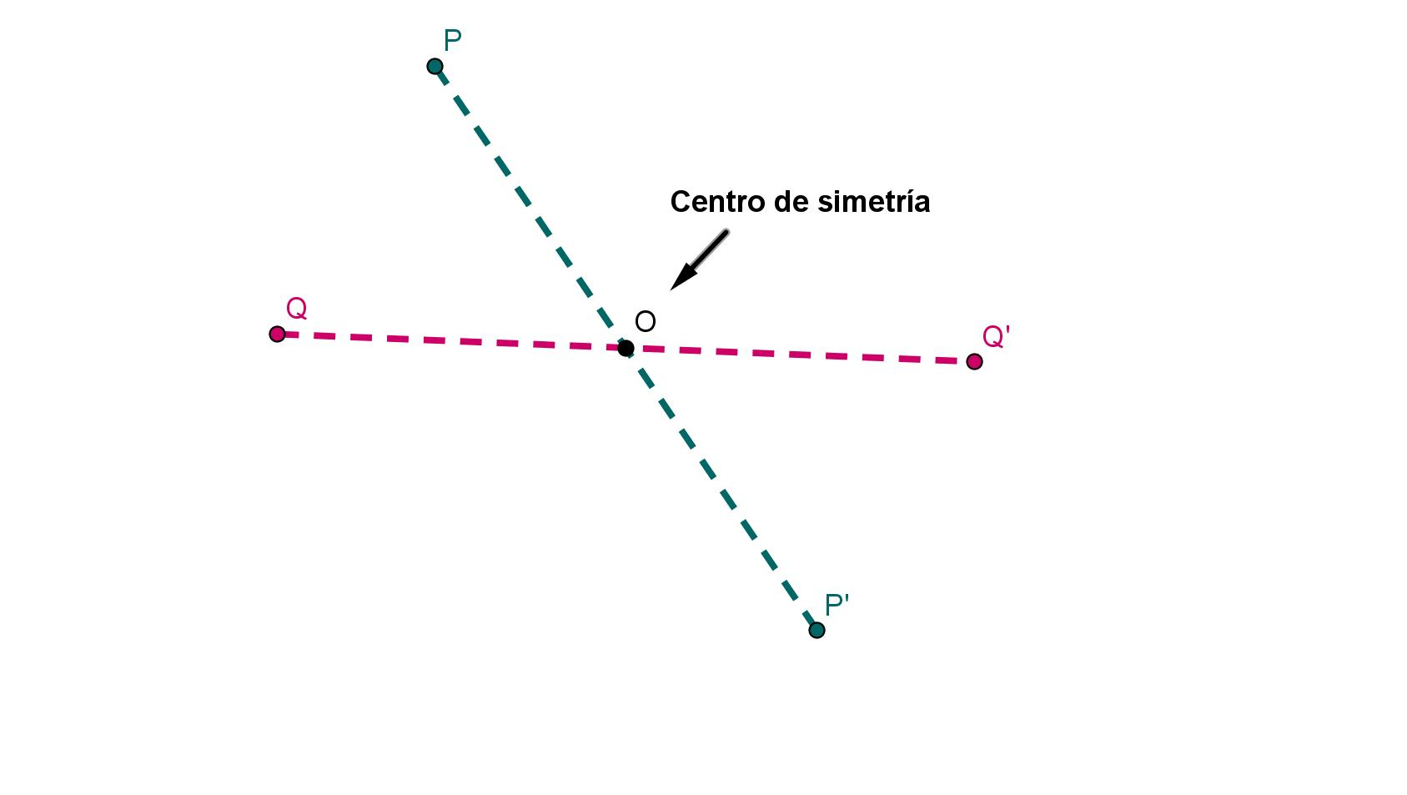
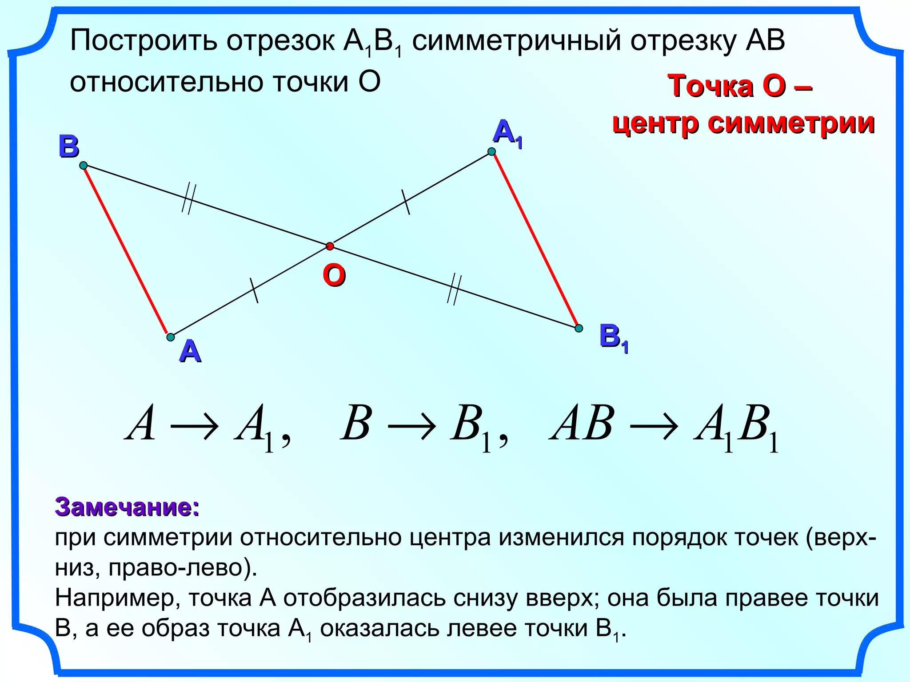

Center of Symmetry
# Source: AI Source: Provided by: [Data Path: Persons Table -> ID Column: 1, Name_En Column: Motasem Essam] -> From: [ChatGPT] on [7/25/2026]
Definition
The center of symmetry is the fixed point about which a figure can be rotated ${180}^{∘}$ and remain unchanged.
It is also the midpoint between every pair of corresponding points.
For corresponding points $A$ and $A'$:
$$\boxed{O=\text{midpoint of }\overline{AA'}}$$
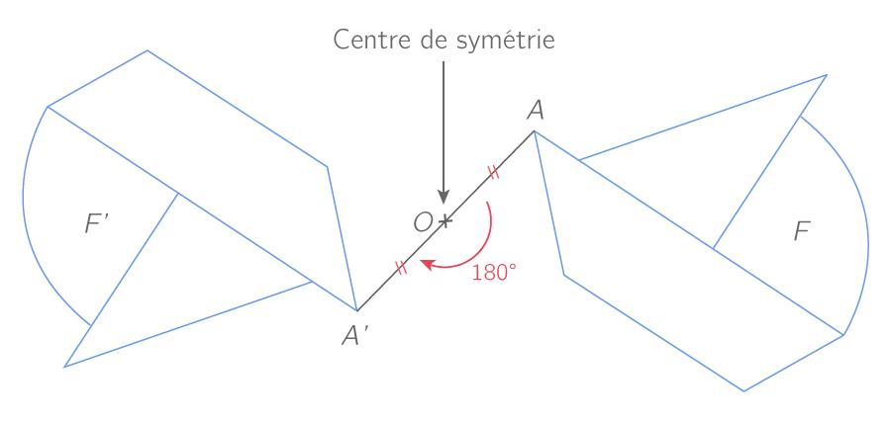
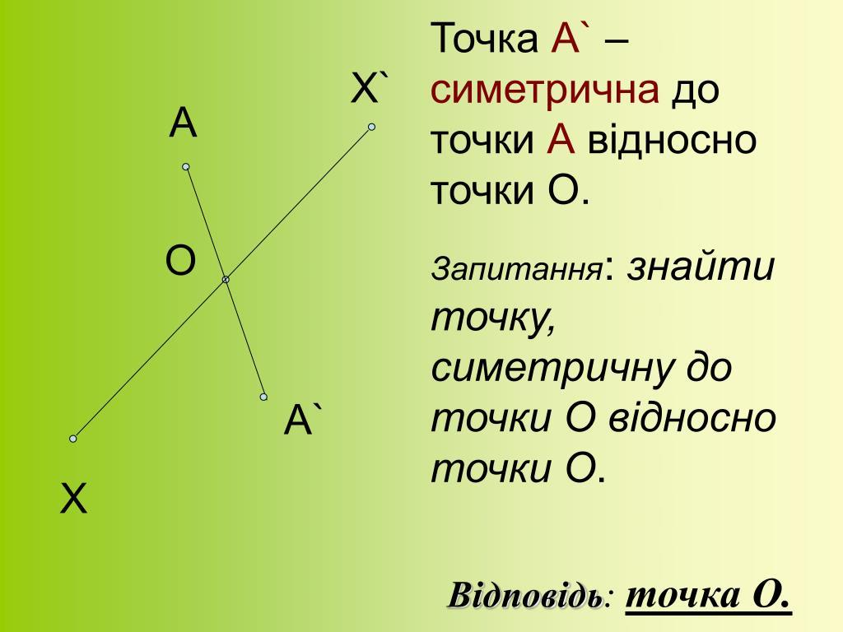
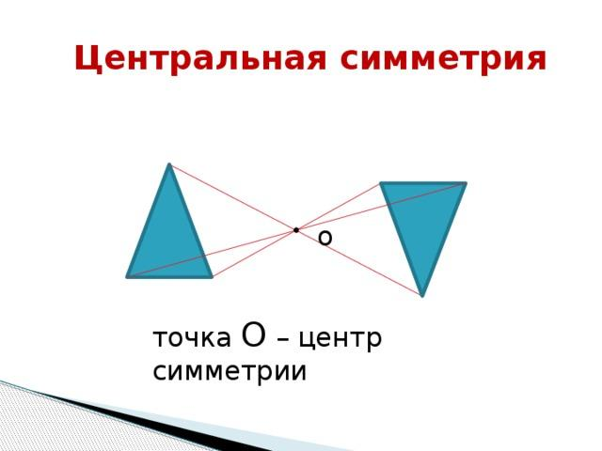
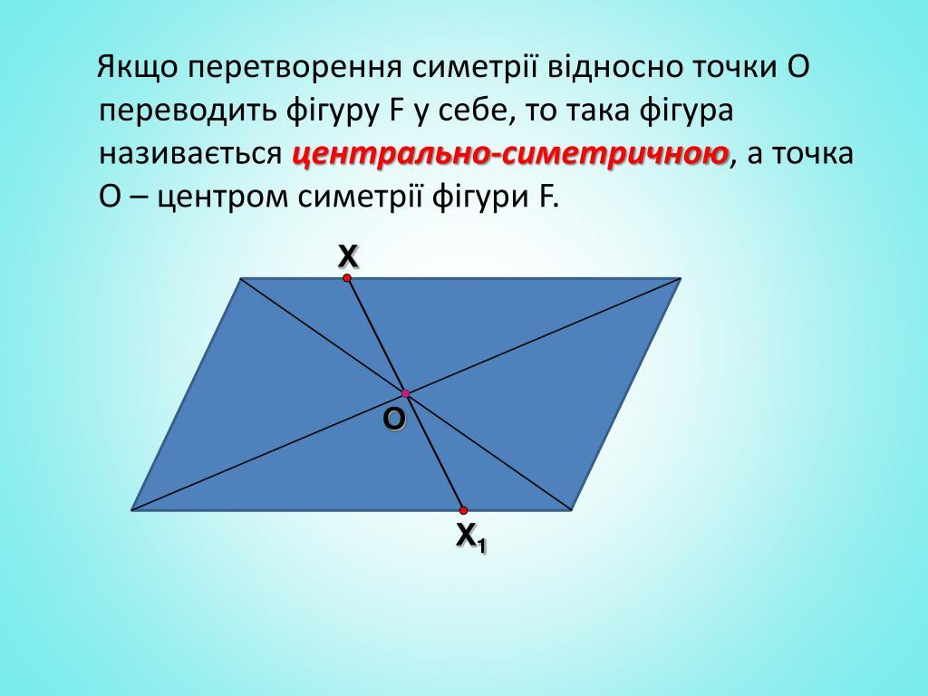

${180}^{∘}$ Rotation
# Source: AI Source: Provided by: [Data Path: Persons Table -> ID Column: 1, Name_En Column: Motasem Essam] -> From: [ChatGPT] on [7/25/2026]
Point symmetry is directly related to rotation.
A complete rotation is:
$${360}^{∘}$$
Point symmetry uses exactly half of a complete rotation:
$$\boxed{\frac{{360}^{∘}}{2}={180}^{∘}}$$
Therefore:
$$\boxed{\text{Point Symmetry}⟺\text{Rotational Symmetry of order }2}$$
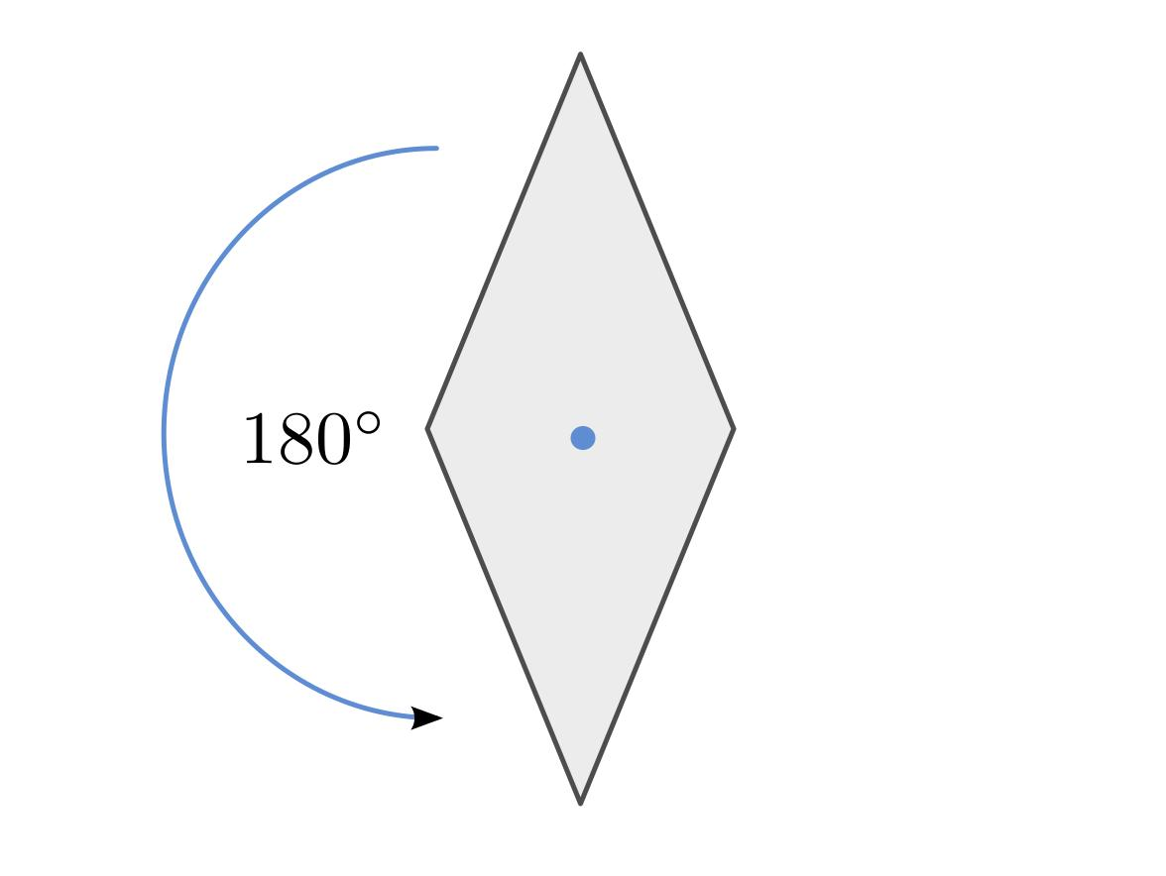
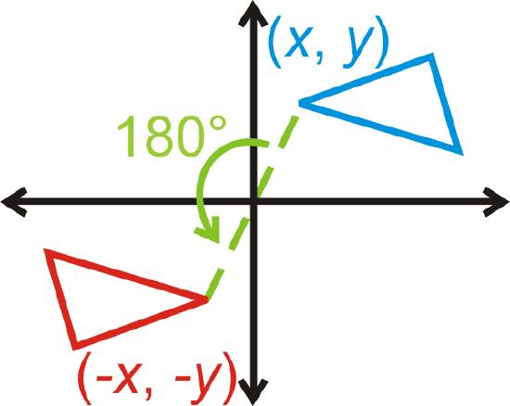
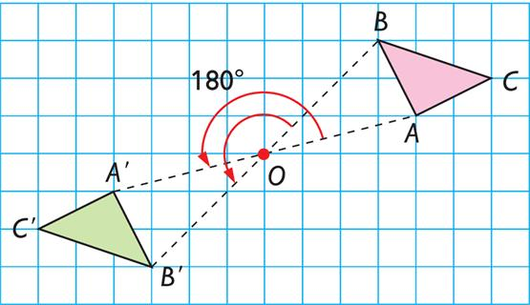
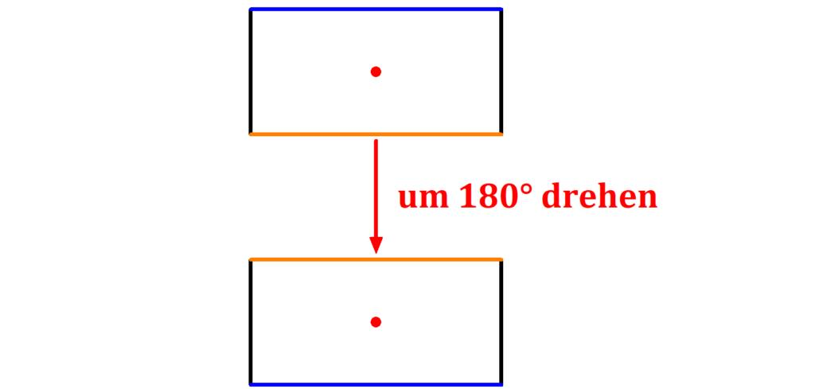
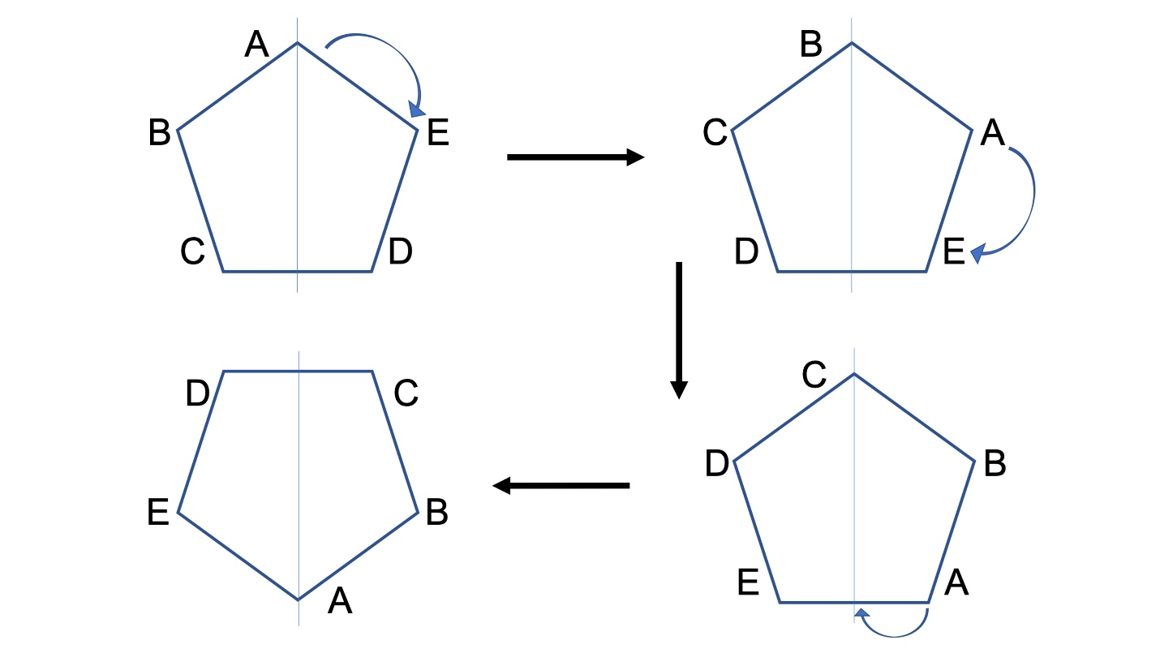
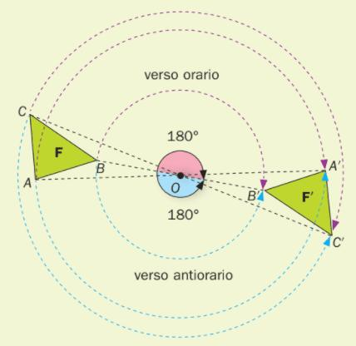

Example: Parallelogram
# Source: AI Source: Provided by: [Data Path: Persons Table -> ID Column: 1, Name_En Column: Motasem Essam] -> From: [ChatGPT] on [7/25/2026]
A general parallelogram has point symmetry.
The center of symmetry is the point where its diagonals intersect.
If the diagonals intersect at $O$:
$$\boxed{OA=OC}$$
and:
$$\boxed{OB=OD}$$
Therefore, rotating the parallelogram by ${180}^{∘}$ about $O$ maps it onto itself.
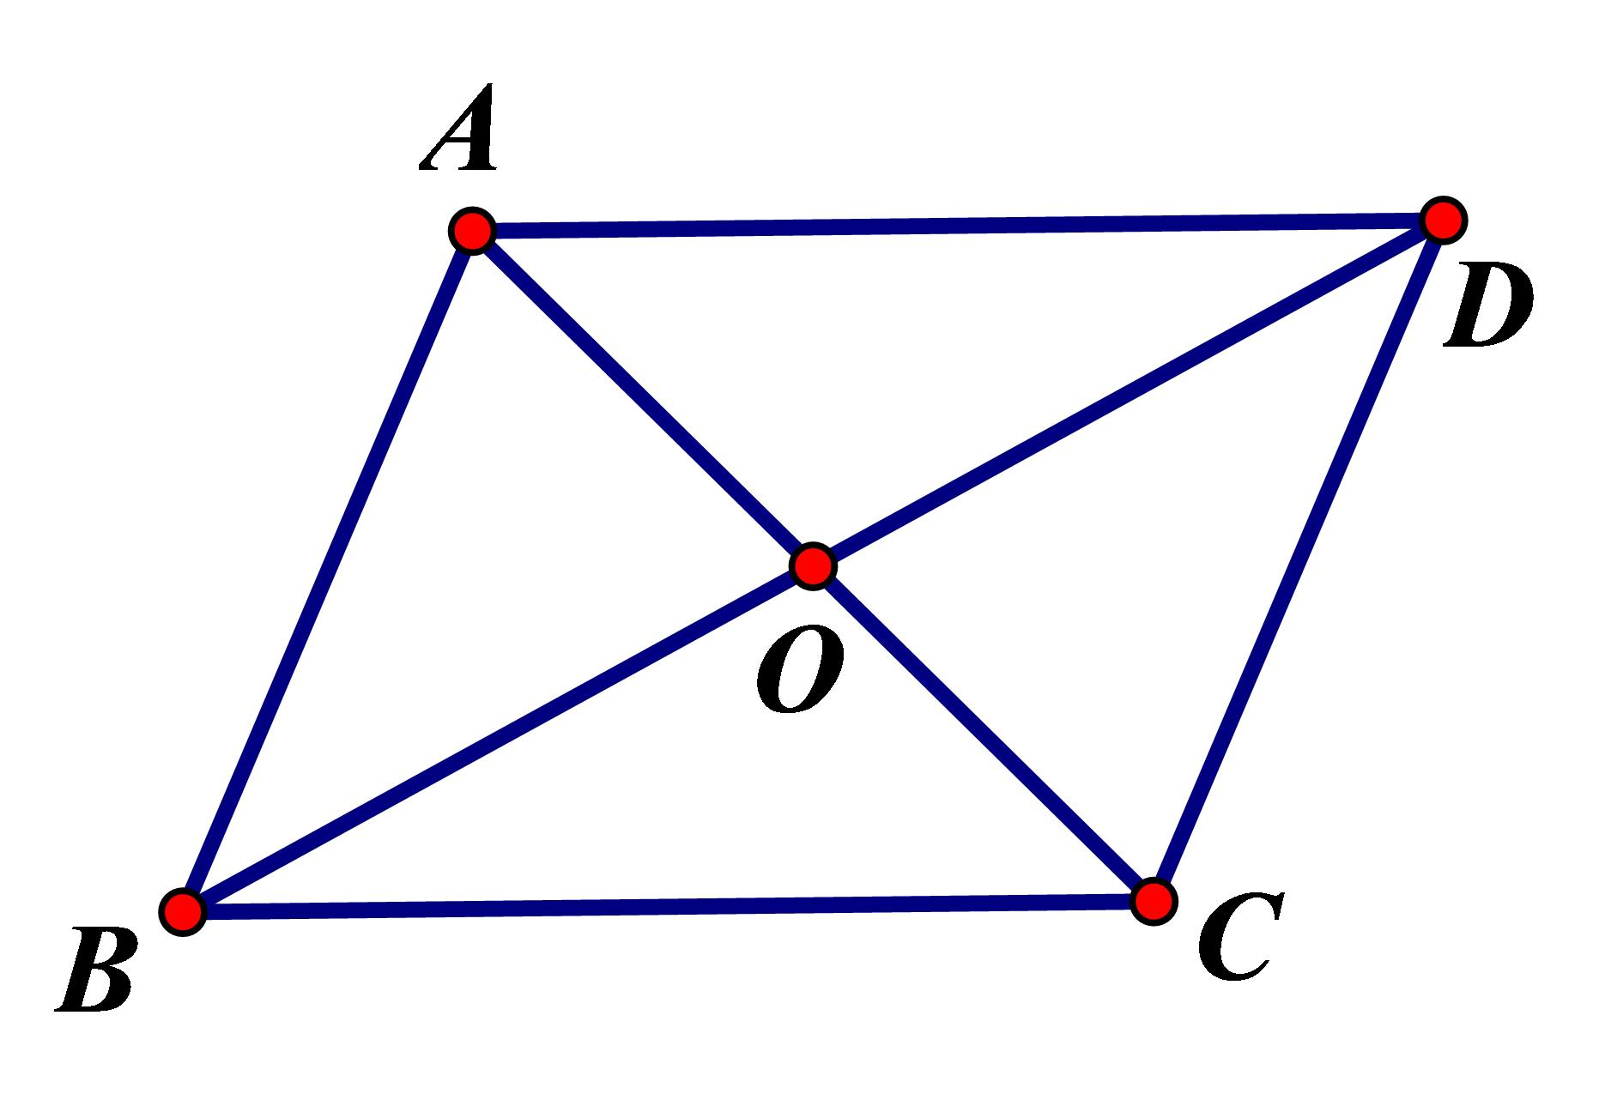
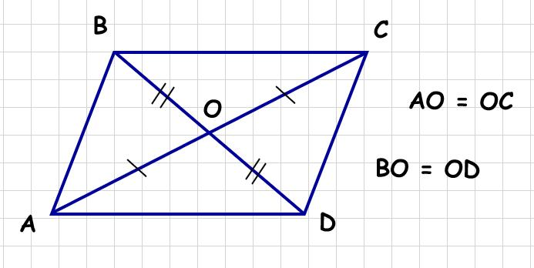
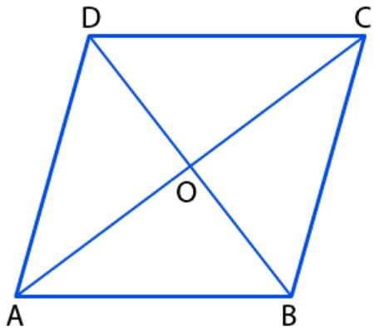

Examples of Figures with Point Symmetry

Rectangle
# Source: AI Source: Provided by: [Data Path: Persons Table -> ID Column: 1, Name_En Column: Motasem Essam] -> From: [ChatGPT] on [7/25/2026]
A rectangle has point symmetry.
Its center is the intersection of its diagonals.
$$\boxed{\text{1 center of symmetry}}$$
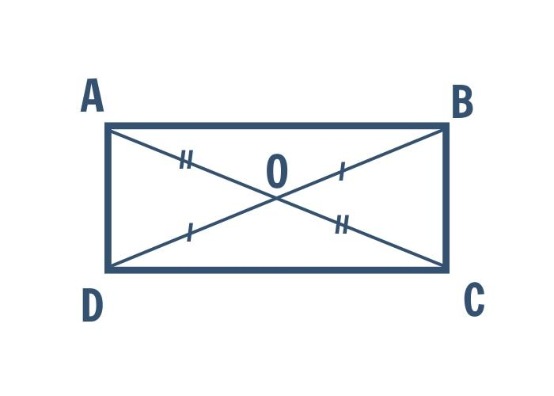
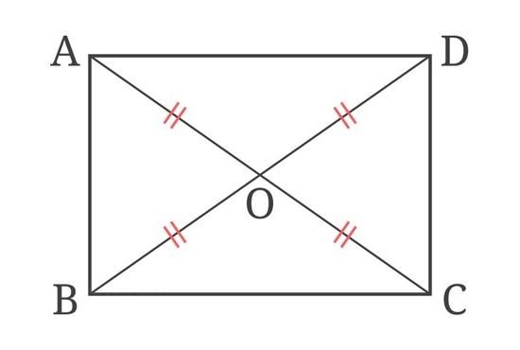
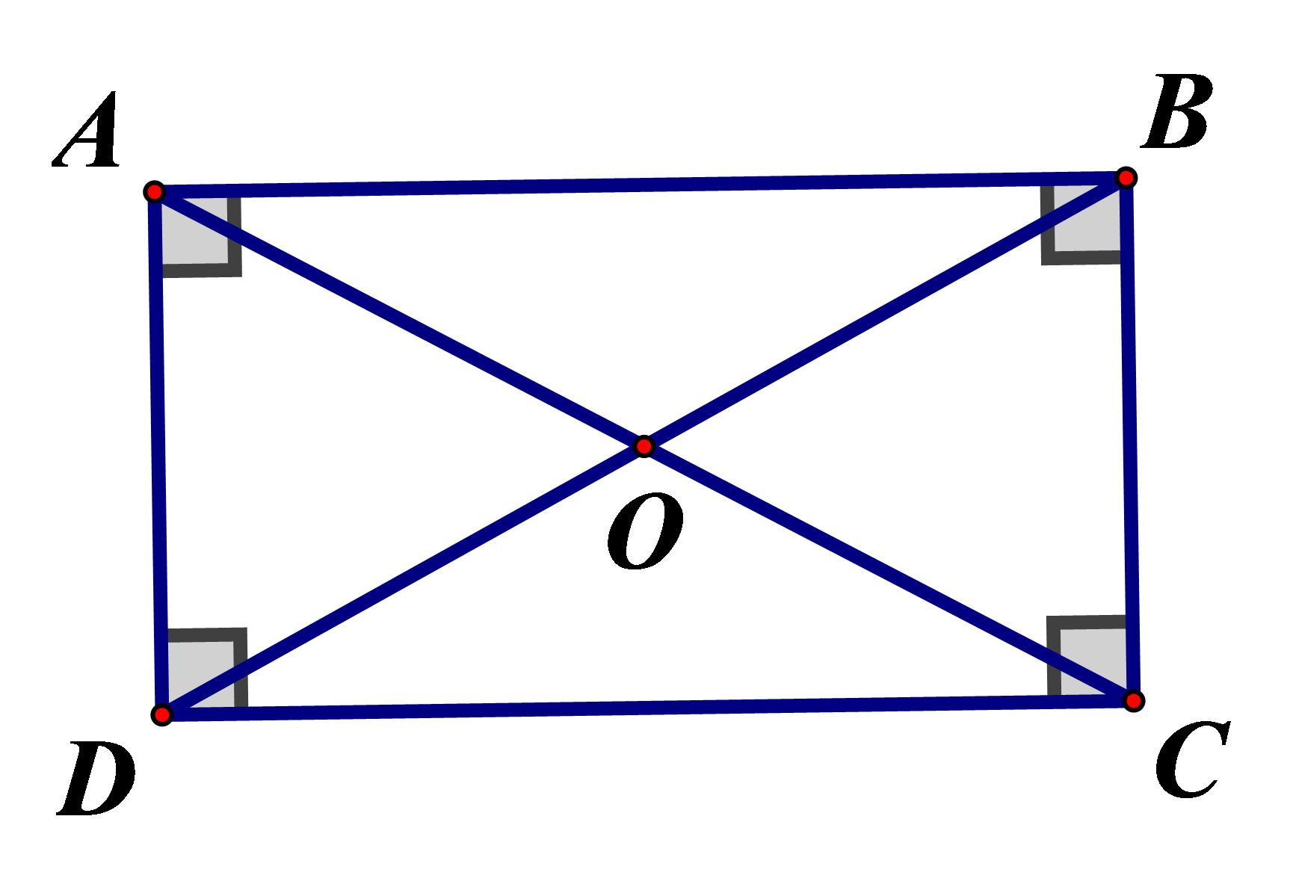
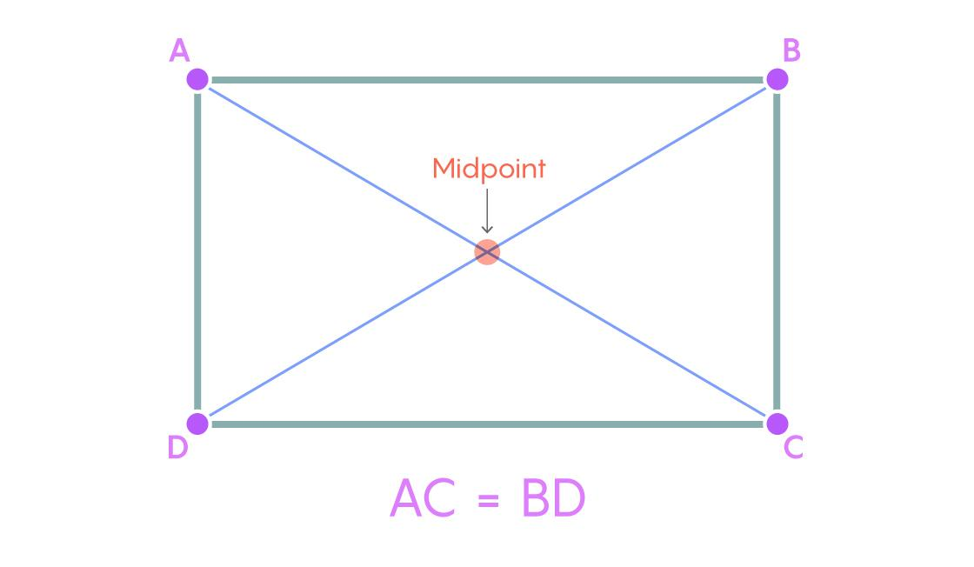

Square
# Source: AI Source: Provided by: [Data Path: Persons Table -> ID Column: 1, Name_En Column: Motasem Essam] -> From: [ChatGPT] on [7/25/2026]
A square also has point symmetry.
Its center is the intersection of its diagonals.
$$\boxed{\text{1 center of symmetry}}$$
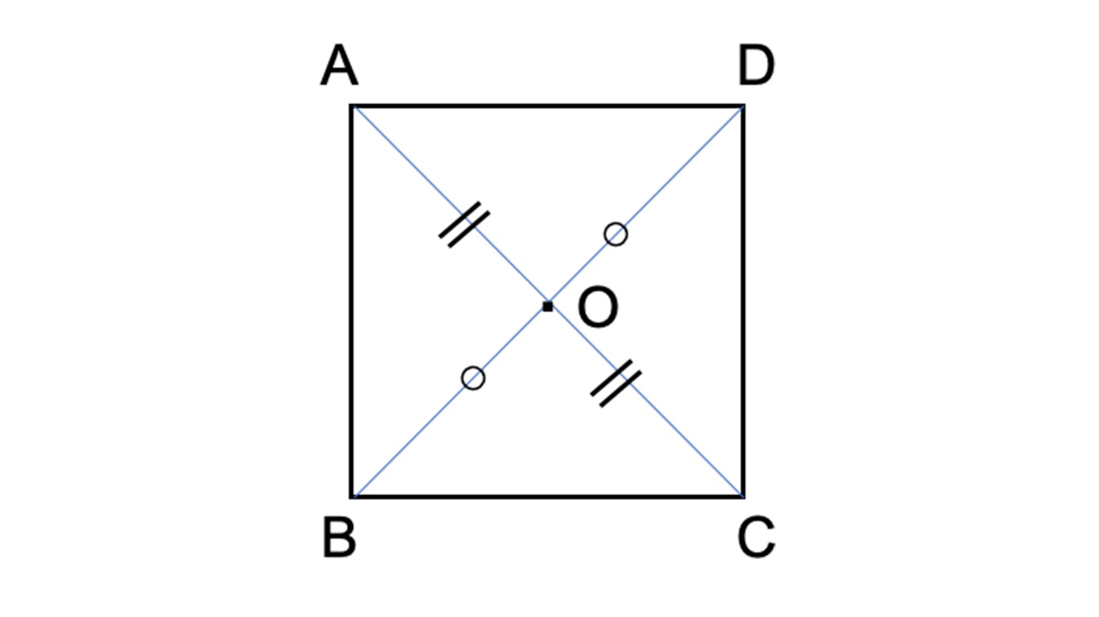
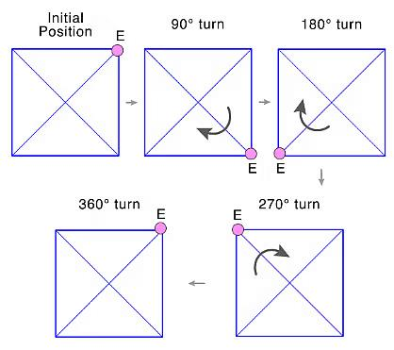
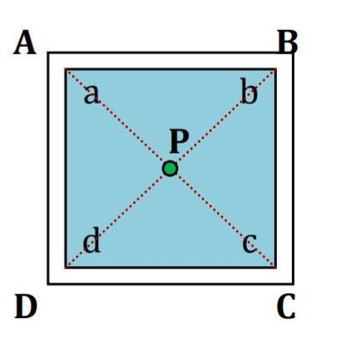
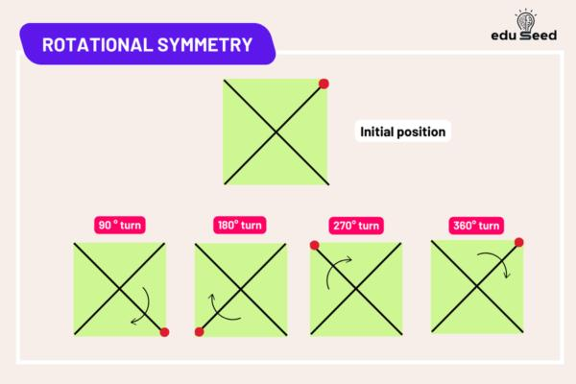
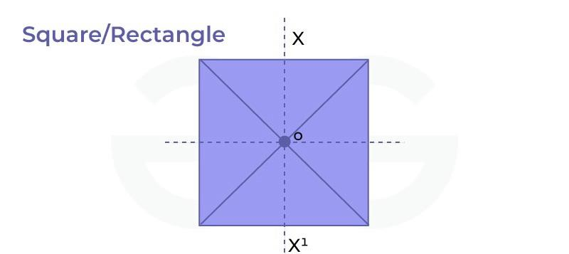

Rhombus
# Source: AI Source: Provided by: [Data Path: Persons Table -> ID Column: 1, Name_En Column: Motasem Essam] -> From: [ChatGPT] on [7/25/2026]
A rhombus has point symmetry at the intersection of its diagonals.
$$\boxed{\text{1 center of symmetry}}$$
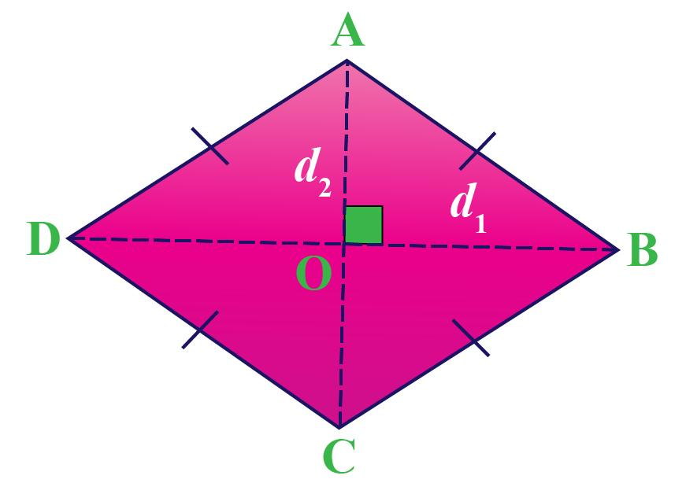
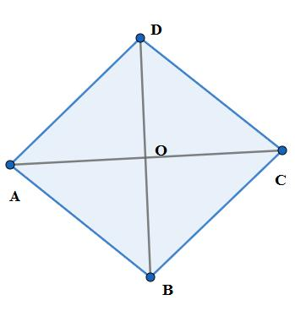
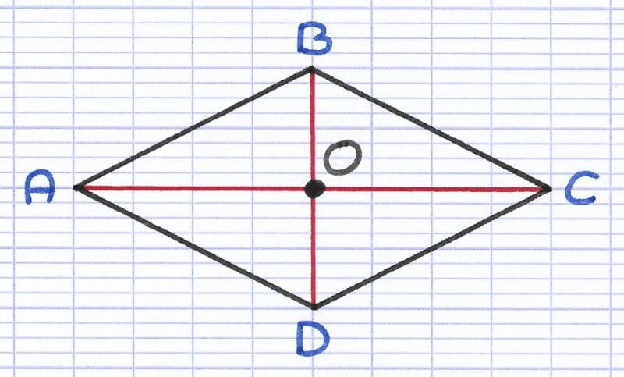
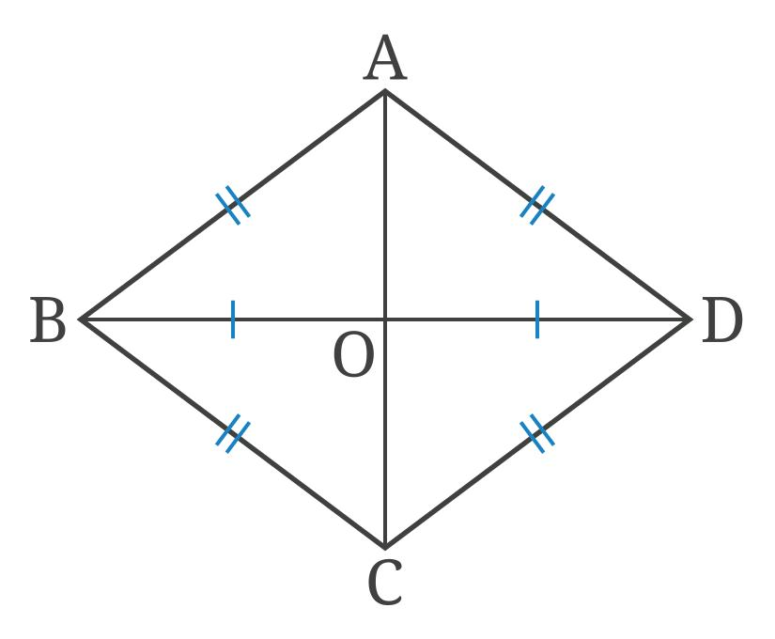

Parallelogram
# Source: AI Source: Provided by: [Data Path: Persons Table -> ID Column: 1, Name_En Column: Motasem Essam] -> From: [ChatGPT] on [7/25/2026]
Every parallelogram has point symmetry at the intersection of its diagonals.
$$\boxed{\text{1 center of symmetry}}$$
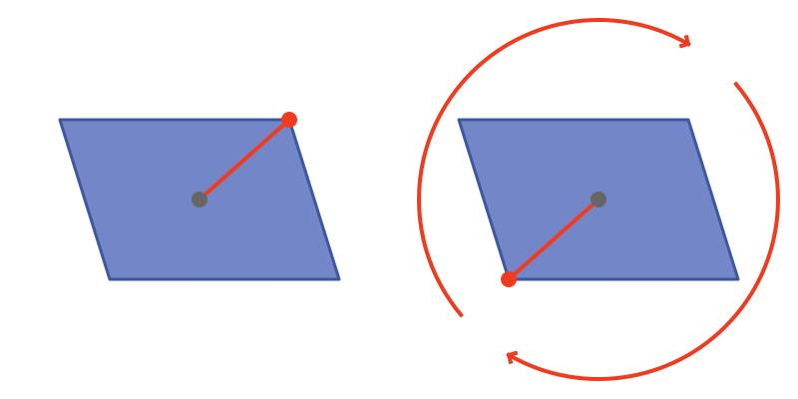
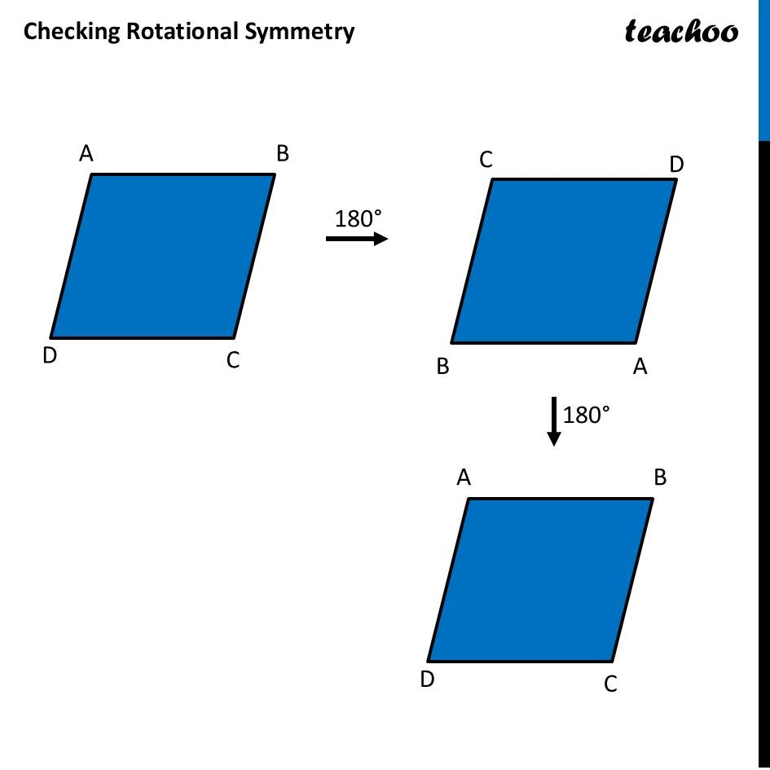
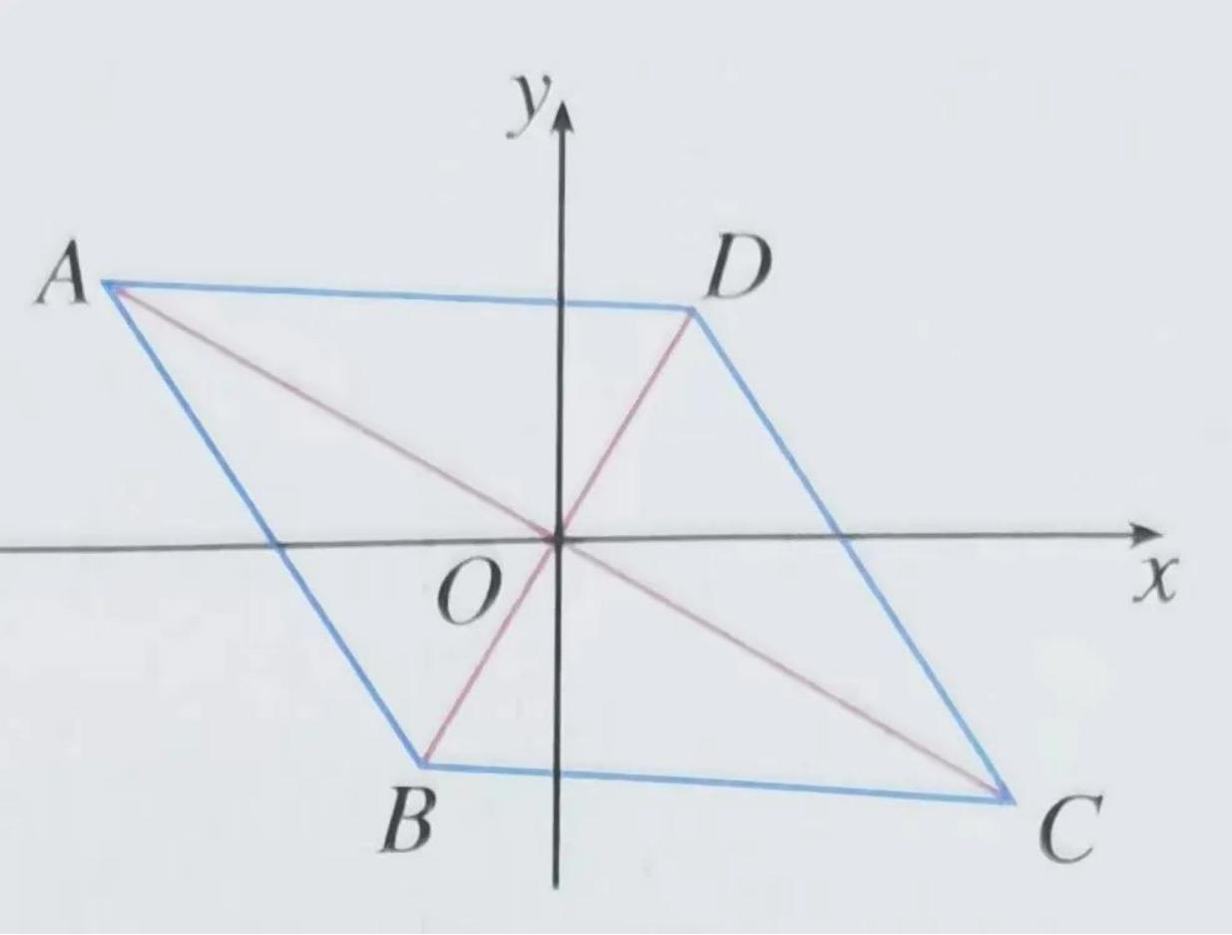

Figures Without Point Symmetry
# Source: AI Source: Provided by: [Data Path: Persons Table -> ID Column: 1, Name_En Column: Motasem Essam] -> From: [ChatGPT] on [7/25/2026]
Not every geometric figure has point symmetry.

General Triangle
# Source: AI Source: Provided by: [Data Path: Persons Table -> ID Column: 1, Name_En Column: Motasem Essam] -> From: [ChatGPT] on [7/25/2026]
A triangle does not have point symmetry.
$$\boxed{\text{No center of symmetry}}$$
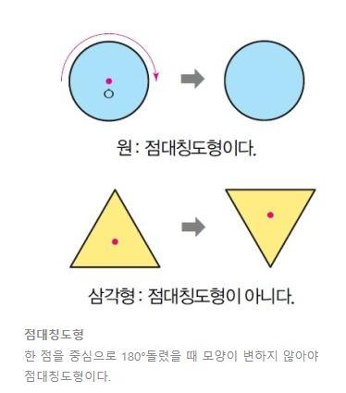
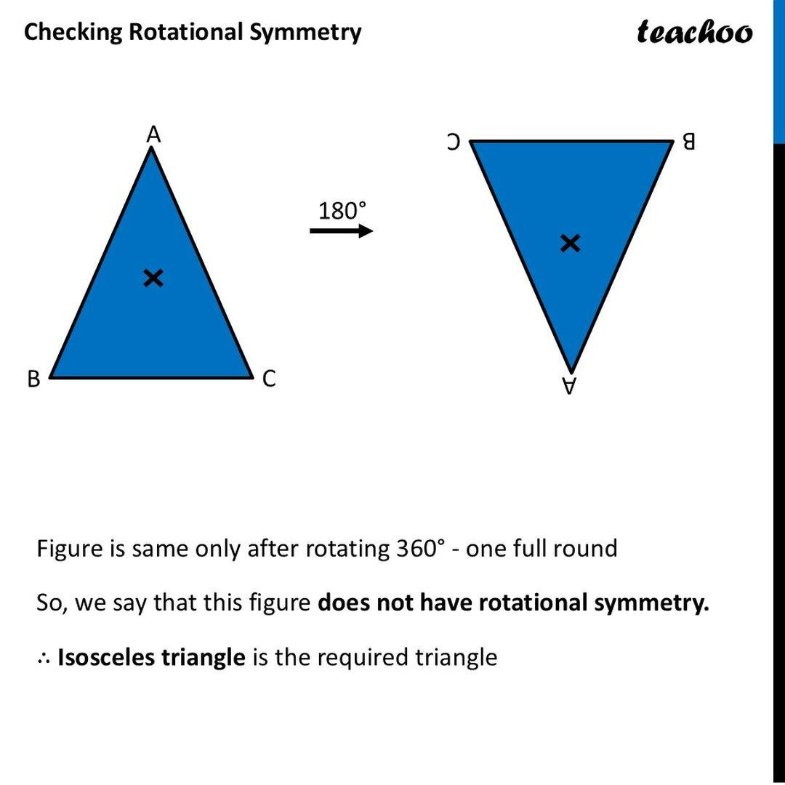
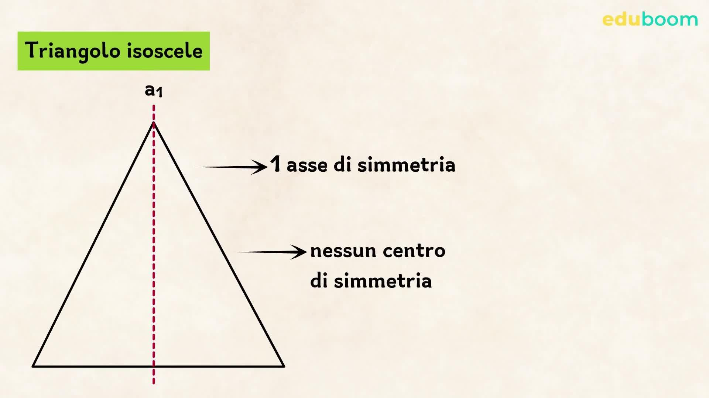
Even an equilateral triangle does not have point symmetry because a (180^\circ) rotation does not map it onto itself.

Trapezoid
# Source: AI Source: Provided by: [Data Path: Persons Table -> ID Column: 1, Name_En Column: Motasem Essam] -> From: [ChatGPT] on [7/25/2026]
A general trapezoid does not have point symmetry.
$$\boxed{\text{No point symmetry}}$$
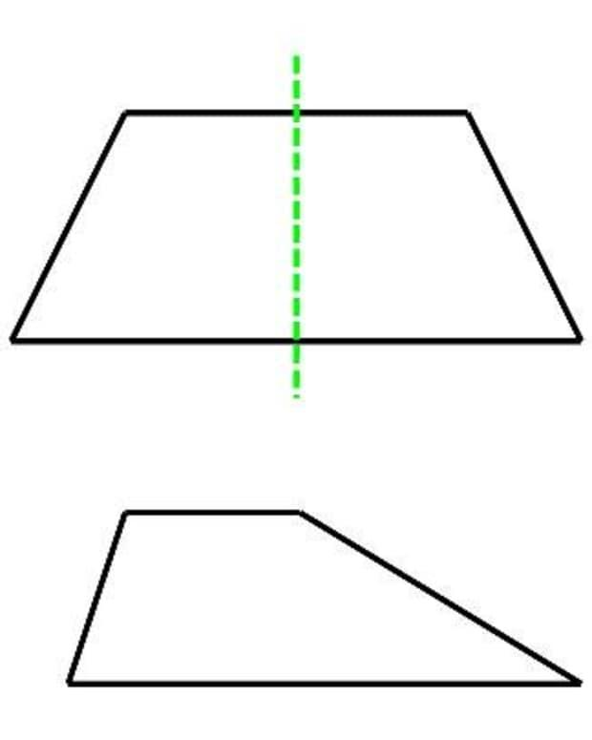
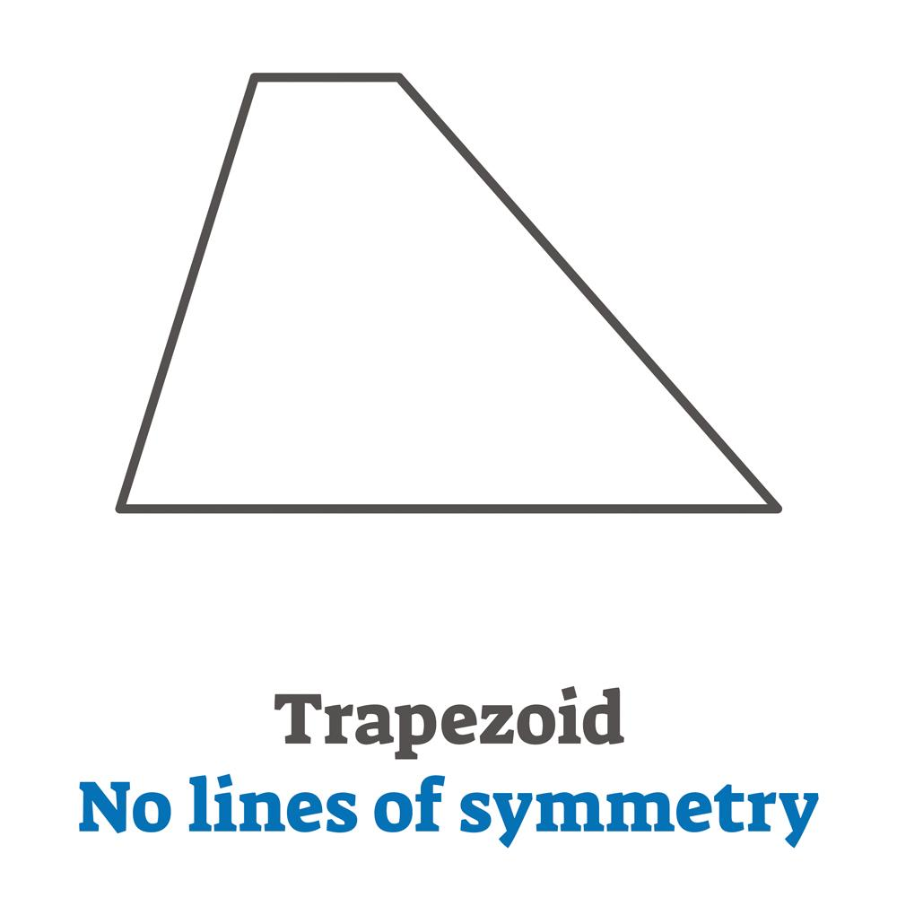
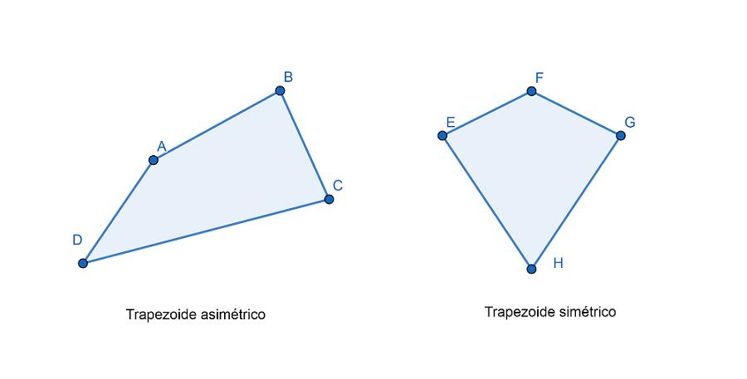

Point Symmetry of Common Figures
# Source: AI Source: Provided by: [Data Path: Persons Table -> ID Column: 1, Name_En Column: Motasem Essam] -> From: [ChatGPT] on [7/25/2026]
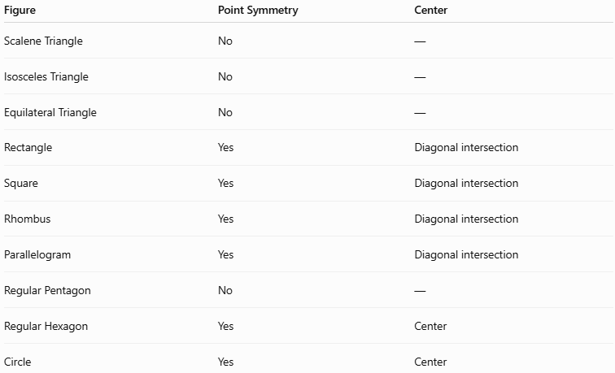
Figure | Point Symmetry | Center
Scalene Triangle | No | —
Isosceles Triangle | No | —
Equilateral Triangle | No | —
Rectangle | Yes | Diagonal intersection
Square | Yes | Diagonal intersection
Rhombus | Yes | Diagonal intersection
Parallelogram | Yes | Diagonal intersection
Regular Pentagon | No | —
Regular Hexagon | Yes | Center
Circle | Yes | Center

Regular Polygons and Point Symmetry
# Source: AI Source: Provided by: [Data Path: Persons Table -> ID Column: 1, Name_En Column: Motasem Essam] -> From: [ChatGPT] on [7/25/2026]
A regular polygon has point symmetry when it has an even number of sides.
Therefore:
$$\boxed{\text{Even-sided regular polygon}→\text{Point symmetry}}$$
Examples:
- Square — $4$ sides.
- Regular hexagon — $6$ sides.
- Regular octagon — $8$ sides.
- Regular decagon — $10$ sides.
Odd-sided regular polygons do not have point symmetry.
Examples:
- Equilateral triangle — $3$ sides.
- Regular pentagon — $5$ sides.
- Regular heptagon — $7$ sides.
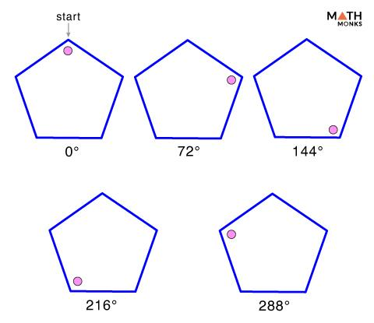
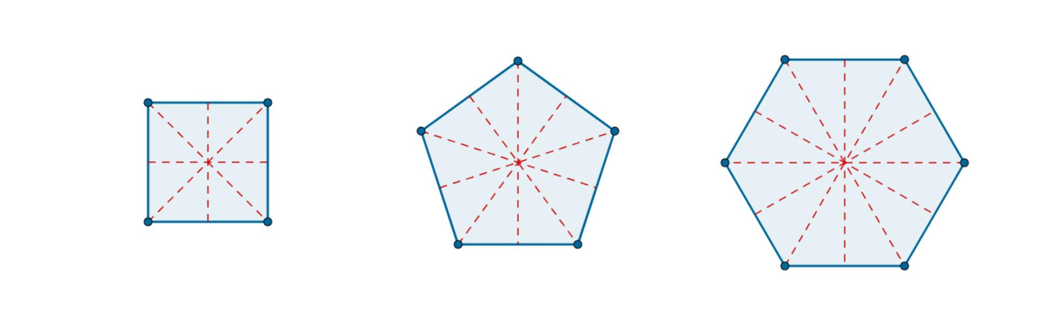

Point Symmetry and Coordinate Geometry
# Source: AI Source: Provided by: [Data Path: Persons Table -> ID Column: 1, Name_En Column: Motasem Essam] -> From: [ChatGPT] on [7/25/2026]
Point symmetry can be described using coordinates.
For a center of symmetry at the origin:
$$O=\left(0,0\right)$$
a point:
$$A=\left(x,y\right)$$
corresponds to:
$$A'=\left(-x,-y\right)$$
Therefore:
$$\boxed{\left(x,y\right)→\left(-x,-y\right)}$$
This is the coordinate rule for a ${180}^{∘}$ rotation about the origin.
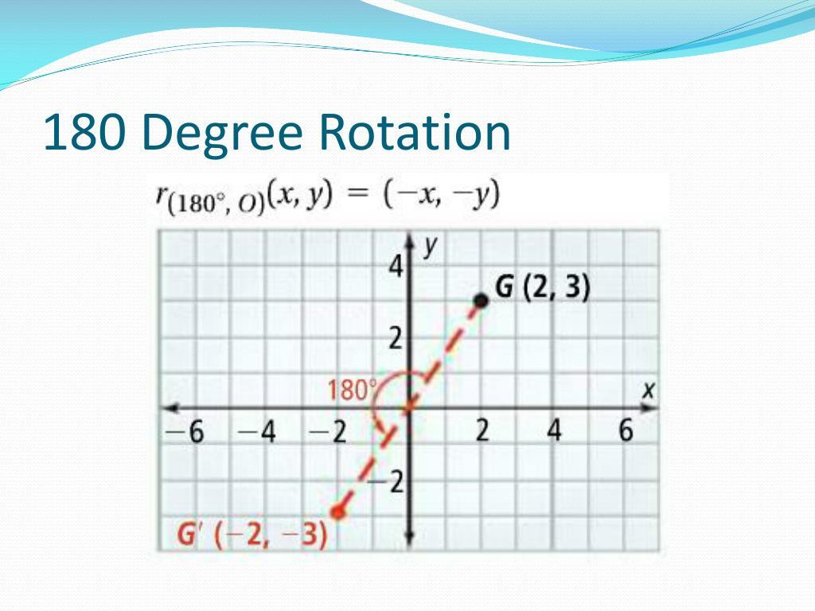
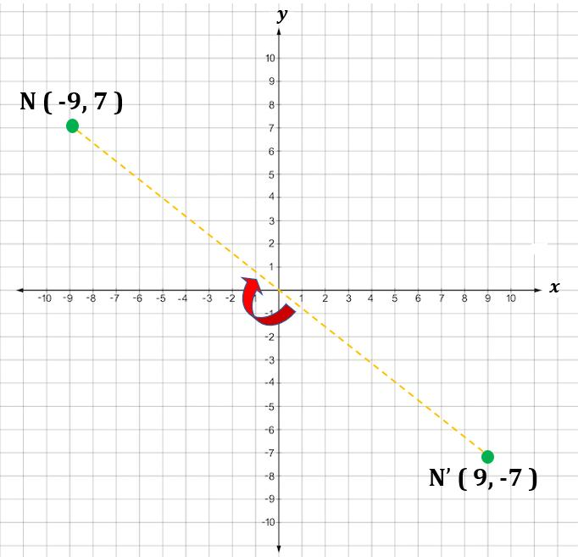
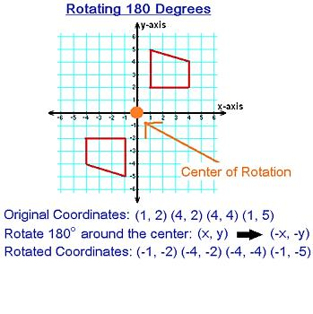

Point Symmetry About a General Point
# Source: AI Source: Provided by: [Data Path: Persons Table -> ID Column: 1, Name_En Column: Motasem Essam] -> From: [ChatGPT] on [7/25/2026]
If the center of symmetry is not the origin, suppose:
$$O=\left(h,k\right)$$
and a point is:
$$A=\left(x,y\right)$$
then its corresponding point $A'$ is:
$$\boxed{A'=\left(2h-x,;2k-y\right)}$$
The center $O$ is the midpoint of $AA'$.

Point Symmetry of Graphs
# Source: AI Source: Provided by: [Data Path: Persons Table -> ID Column: 1, Name_En Column: Motasem Essam] -> From: [ChatGPT] on [7/25/2026]
Point symmetry can also occur in graphs.
For example, the graph of:
$$y=x^{3}$$
has point symmetry about the origin.
If:
$$\left(x,y\right)$$
is on the graph, then:
$$\left(-x,-y\right)$$
is also on the graph.
Therefore:
$$\boxed{f\left(-x\right)=-f\left(x\right)}$$
This is the property of an odd function.
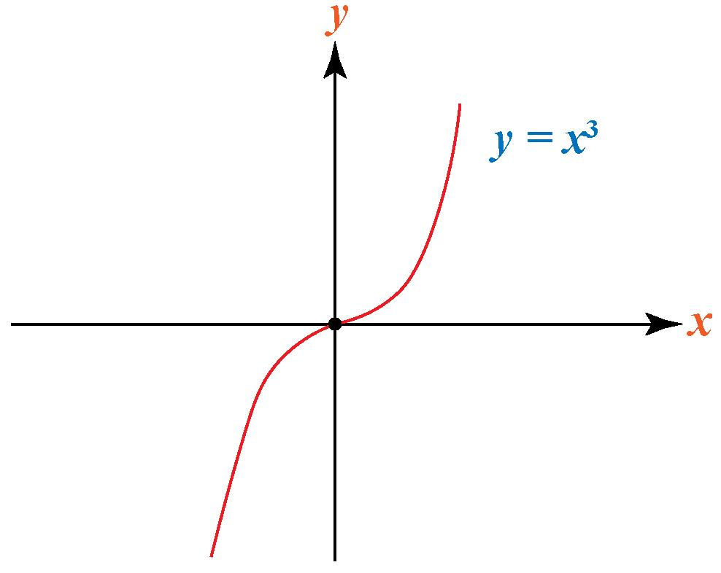
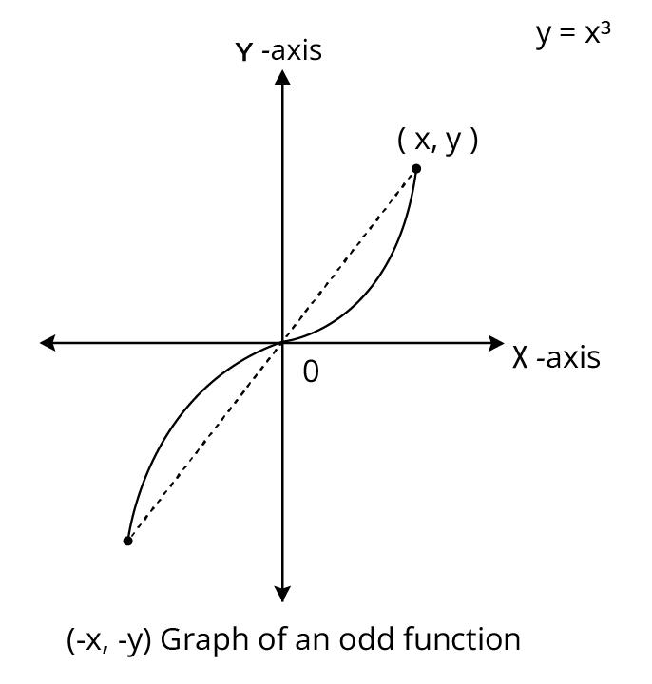
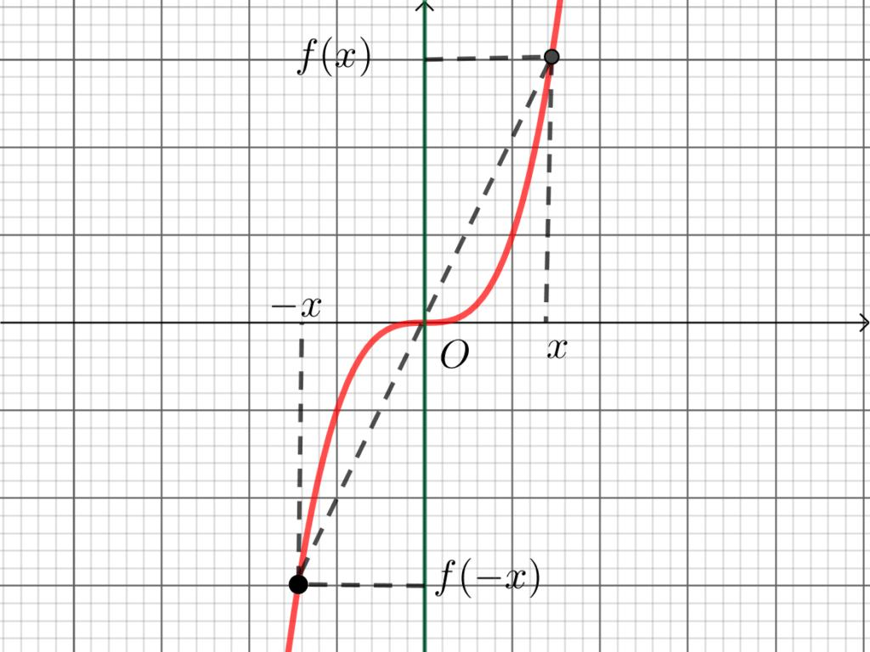
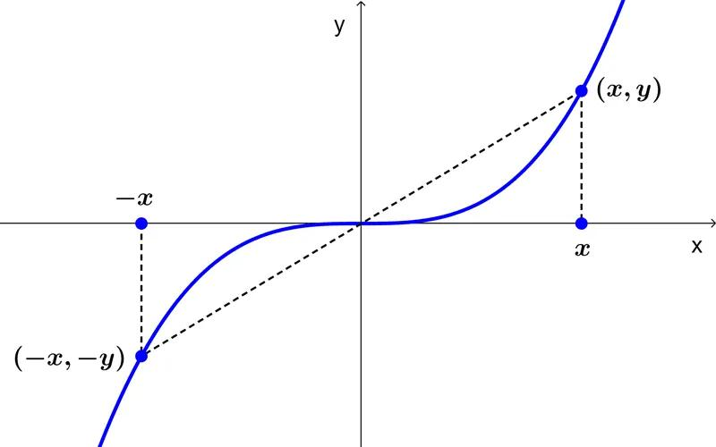

Point Symmetry and Line Symmetry
# Source: AI Source: Provided by: [Data Path: Persons Table -> ID Column: 1, Name_En Column: Motasem Essam] -> From: [ChatGPT] on [7/25/2026]
Point symmetry and line symmetry are different types of symmetry.

Line Symmetry
# Source: AI Source: Provided by: [Data Path: Persons Table -> ID Column: 1, Name_En Column: Motasem Essam] -> From: [ChatGPT] on [7/25/2026]
A figure is reflected across a line:
$$\boxed{\text{Reflection}}$$

Point Symmetry
# Source: AI Source: Provided by: [Data Path: Persons Table -> ID Column: 1, Name_En Column: Motasem Essam] -> From: [ChatGPT] on [7/25/2026]
A figure is rotated ${180}^{∘}$ around a point:
$$\boxed{{180}^{∘}\text{ Rotation}}$$
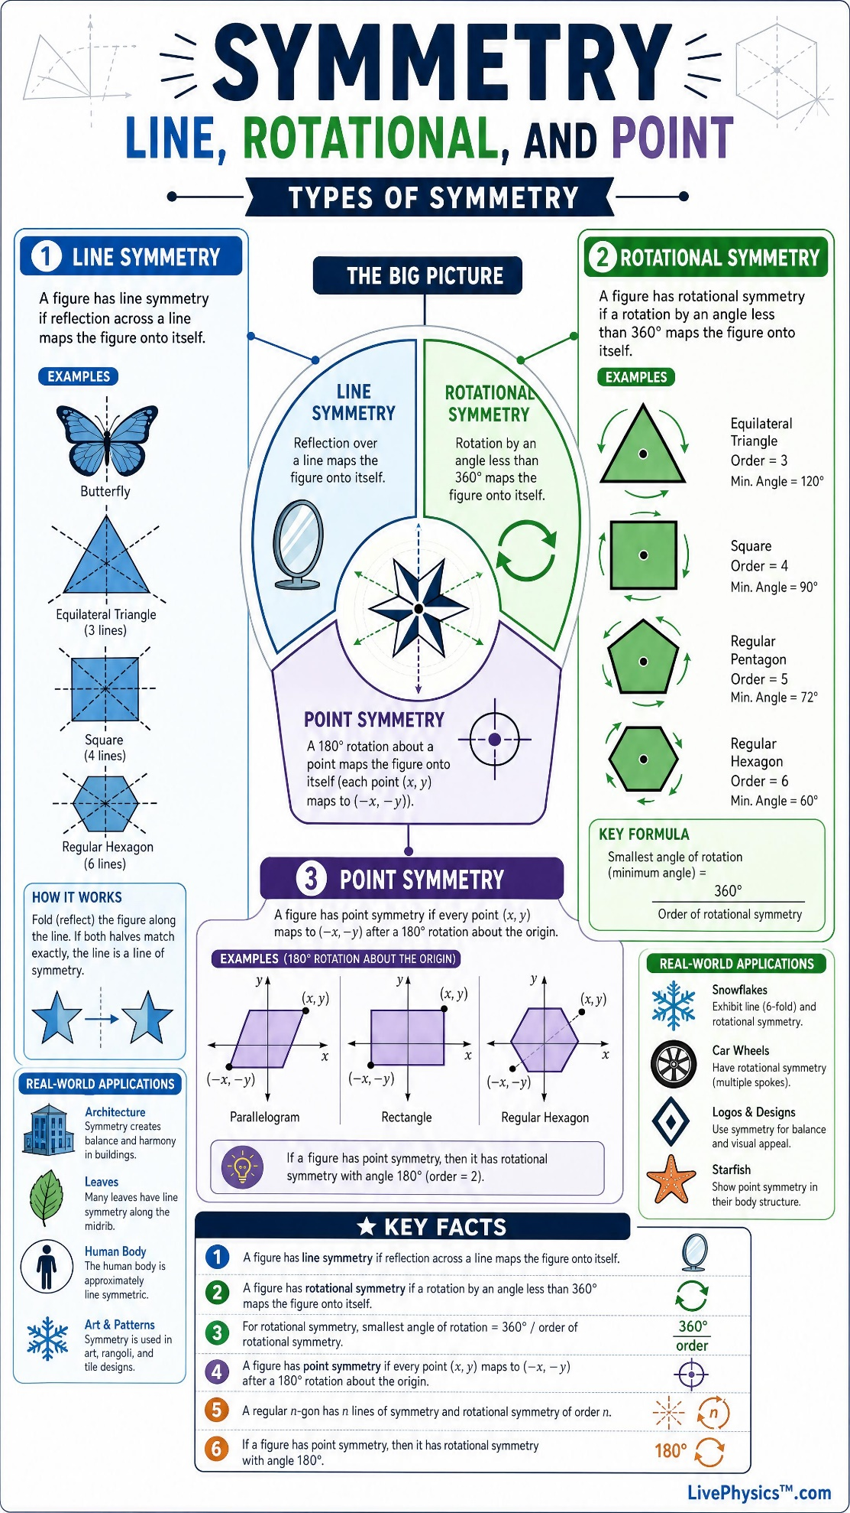
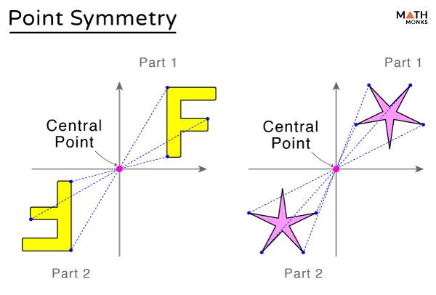
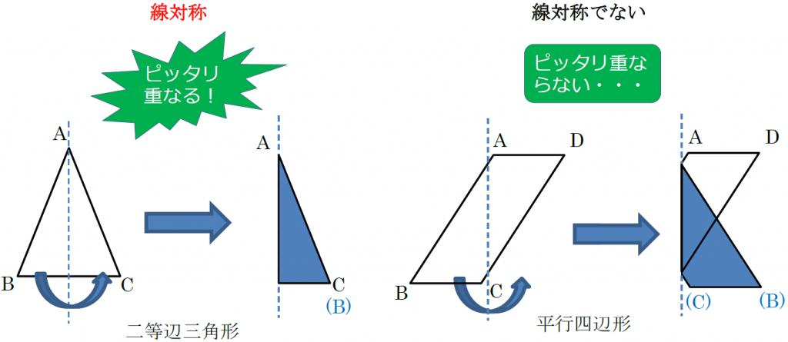
A figure can have both types.
For example, a square has:
$$4\text{ lines of symmetry}$$
and:
$$1\text{ center of point symmetry}$$

Point Symmetry and Rotational Symmetry
# Source: AI Source: Provided by: [Data Path: Persons Table -> ID Column: 1, Name_En Column: Motasem Essam] -> From: [ChatGPT] on [7/25/2026]
Point symmetry is a special case of rotational symmetry.
If a figure has point symmetry, it must remain unchanged after:
$${180}^{∘}$$
rotation.
Therefore, its rotational symmetry has order:
$$\boxed{2}$$
For example, a parallelogram has rotational symmetry of order $2$.
$$\boxed{\text{Point Symmetry}⊂\text{Rotational Symmetry}}$$
in this sense.

Point Symmetry and Congruence
# Source: AI Source: Provided by: [Data Path: Persons Table -> ID Column: 1, Name_En Column: Motasem Essam] -> From: [ChatGPT] on [7/25/2026]
Rotation preserves:
- Length.
- Angle.
- Shape.
- Area.
Therefore, when a figure is rotated ${180}^{∘}$, the resulting figure is congruent to the original:
$$\boxed{\text{Original}≅\text{Rotated Figure}}$$
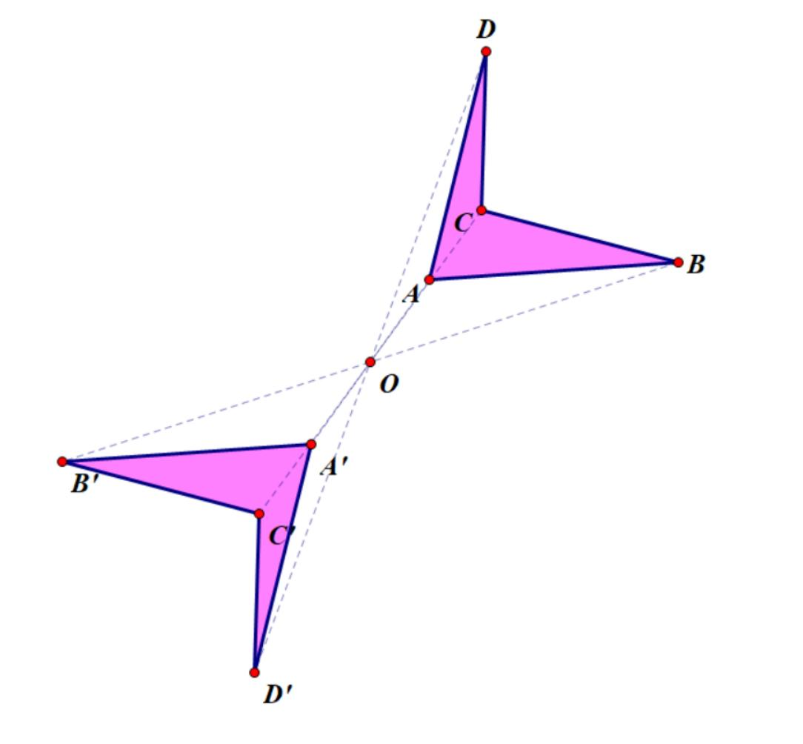
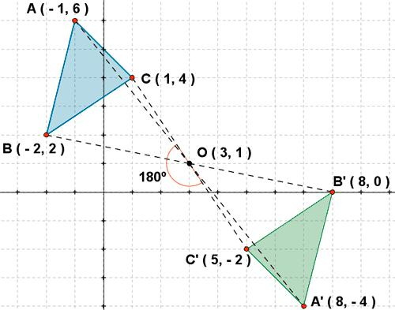
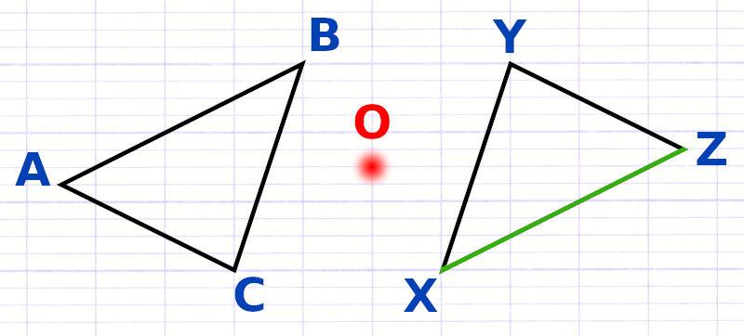

Point Symmetry and Diagonals
# Source: AI Source: Provided by: [Data Path: Persons Table -> ID Column: 1, Name_En Column: Motasem Essam] -> From: [ChatGPT] on [7/25/2026]
In several common geometric figures, the center of point symmetry is related to the intersection of diagonals.
For a parallelogram:
$$\boxed{\text{Diagonals bisect each other}}$$
Their intersection is the center of symmetry.
This also applies to:
- Rectangle.
- Rhombus.
- Square.
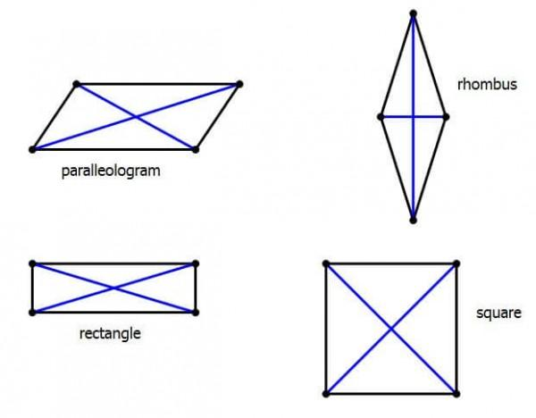
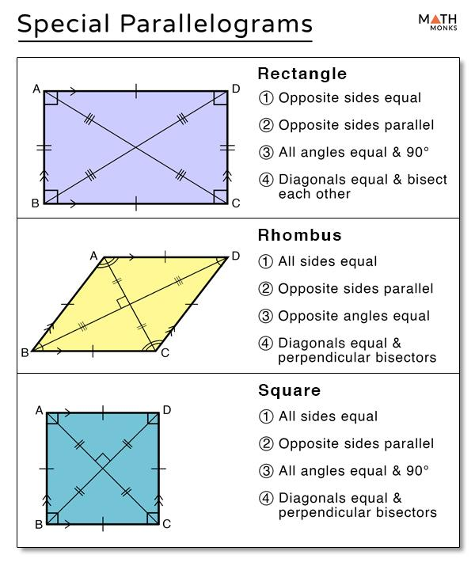
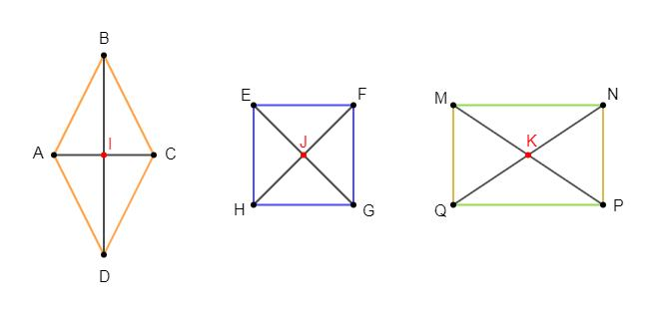

Point Symmetry in Nature
# Source: AI Source: Provided by: [Data Path: Persons Table -> ID Column: 1, Name_En Column: Motasem Essam] -> From: [ChatGPT] on [7/25/2026]
Point or ${180}^{∘}$ symmetry can occur in some natural patterns and structures.
Examples can include:
- Certain leaves and patterns.
- Some flowers.
- Crystals.
- Certain biological structures.
- Repeating natural patterns.
Natural examples are generally approximate rather than mathematically perfect.

Point Symmetry in Architecture and Design
# Source: AI Source: Provided by: [Data Path: Persons Table -> ID Column: 1, Name_En Column: Motasem Essam] -> From: [ChatGPT] on [7/25/2026]
Point symmetry can be used to create balanced designs around a central point.
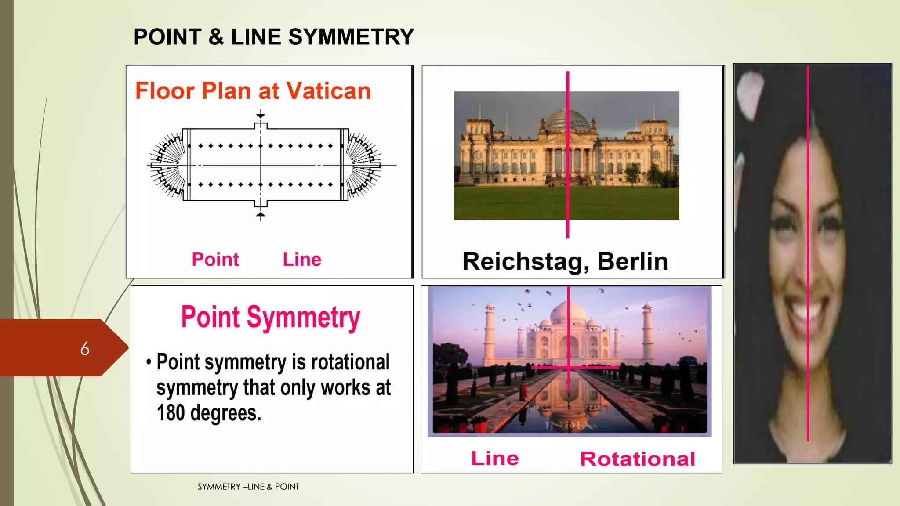
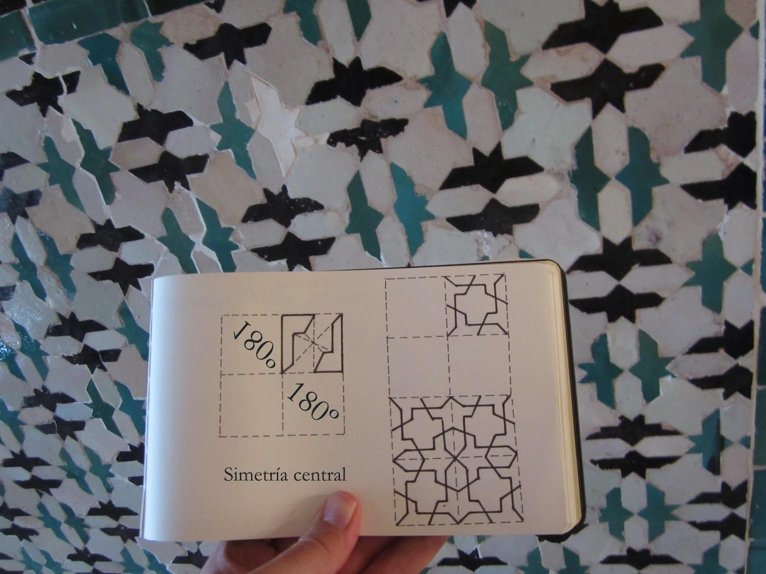
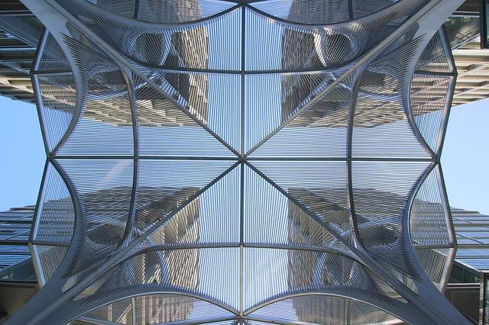
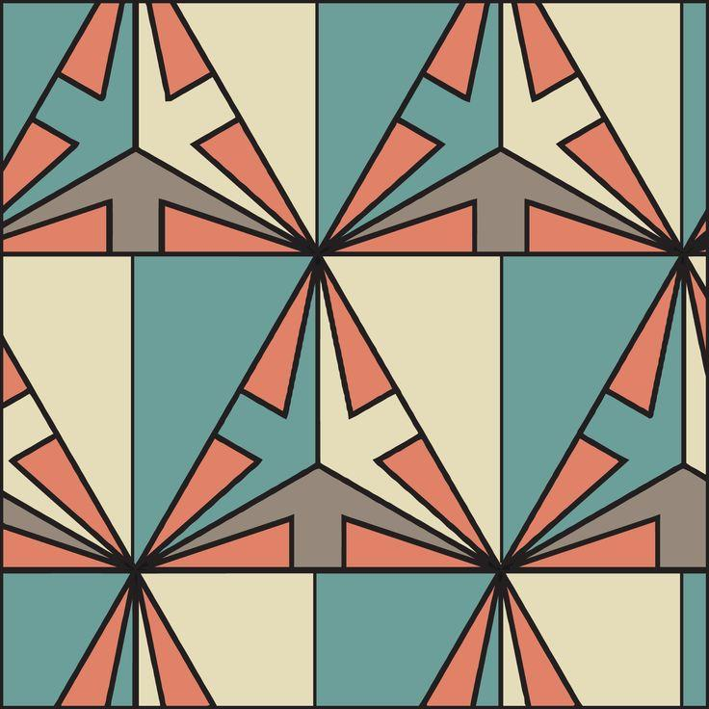
Applications include:
- Decorative patterns.
- Floor designs.
- Logos.
- Tiles.
- Architectural layouts.
- Graphic design.

Point Symmetry in Computer Graphics
# Source: AI Source: Provided by: [Data Path: Persons Table -> ID Column: 1, Name_En Column: Motasem Essam] -> From: [ChatGPT] on [7/25/2026]
Point symmetry can be generated by rotating an object ${180}^{∘}$ around a specified center.
For example:
- Create an object.
- Select the center of symmetry.
- Rotate the object by ${180}^{∘}$.
- Combine the original and rotated objects.
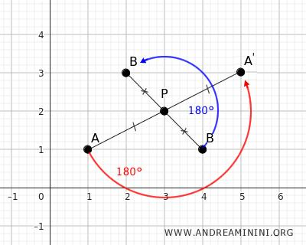
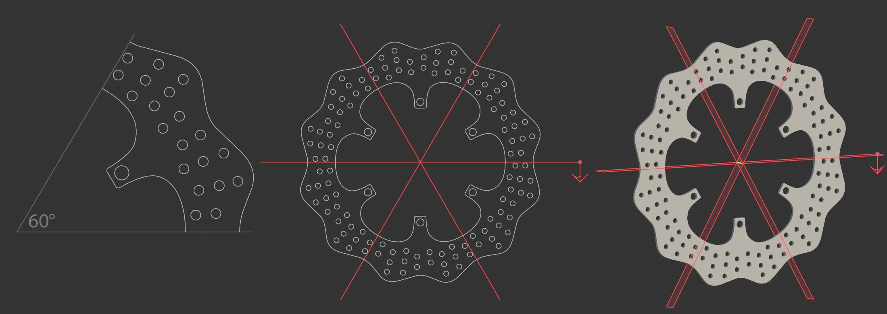
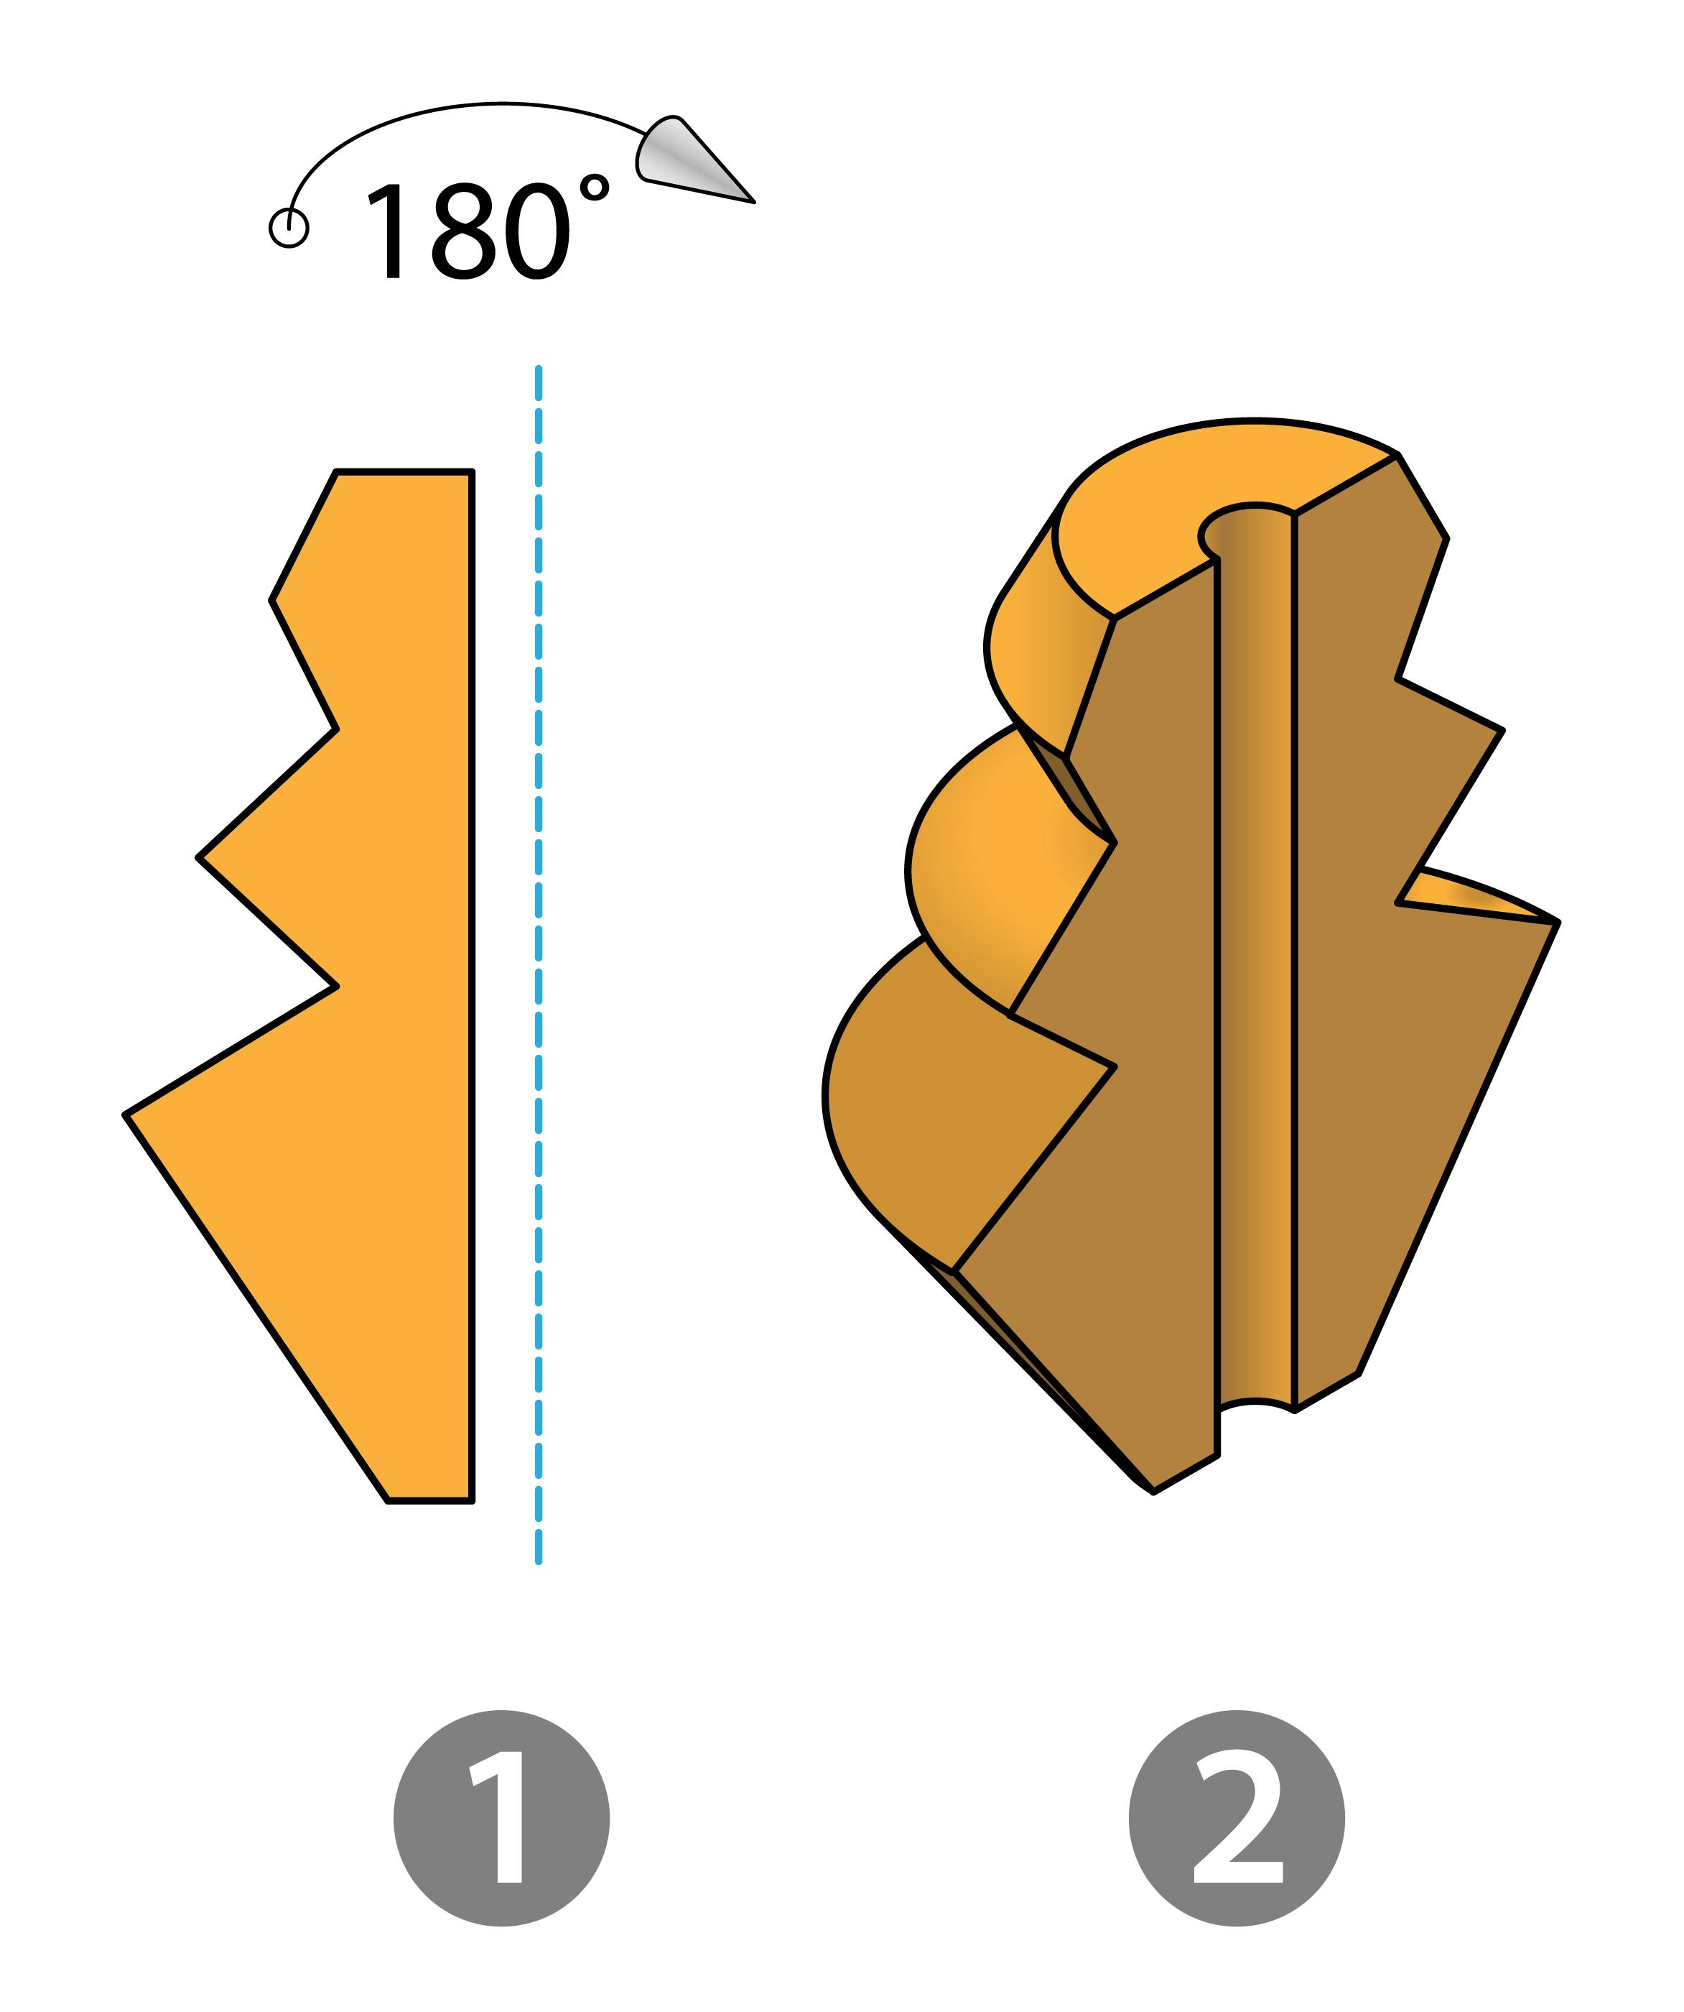

Applications
# Source: AI Source: Provided by: [Data Path: Persons Table -> ID Column: 1, Name_En Column: Motasem Essam] -> From: [ChatGPT] on [7/25/2026]
Point symmetry is important in:
- Plane Geometry
- Geometric Transformations
- Coordinate Geometry
- Algebra
- Architecture
- Engineering
- CAD
- Computer Graphics
- Pattern Design
- Art
- Crystallography

Advantages
# Source: AI Source: Provided by: [Data Path: Persons Table -> ID Column: 1, Name_En Column: Motasem Essam] -> From: [ChatGPT] on [7/25/2026]
Studying point symmetry helps to:
- Identify ${180}^{∘}$ rotational relationships.
- Find centers of symmetry.
- Understand rotations.
- Analyze opposite points.
- Understand parallelogram properties.
- Analyze coordinate graphs.
- Identify symmetry in mathematical functions.
- Create balanced geometric designs.
- Develop spatial reasoning.

Limitations
# Source: AI Source: Provided by: [Data Path: Persons Table -> ID Column: 1, Name_En Column: Motasem Essam] -> From: [ChatGPT] on [7/25/2026]
Point symmetry:
- Does not exist in every geometric figure.
- Requires a specific center of symmetry.
- Is specifically associated with a ${180}^{∘}$ rotation.
- May be difficult to identify in complex or irregular figures.
- Does not imply line symmetry.
- Real-world objects may only approximately possess point symmetry.

Comparison with Related Concepts
# Source: AI Source: Provided by: [Data Path: Persons Table -> ID Column: 1, Name_En Column: Motasem Essam] -> From: [ChatGPT] on [7/25/2026]
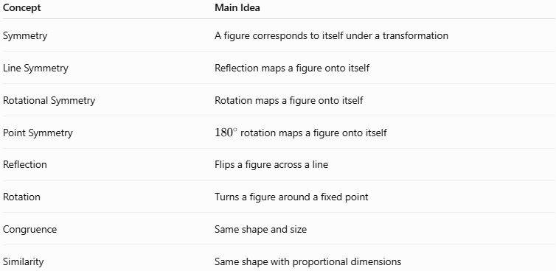
Concept | Main Idea
Symmetry | A figure corresponds to itself under a transformation
Line Symmetry | Reflection maps a figure onto itself
Rotational Symmetry | Rotation maps a figure onto itself
Point Symmetry | ${180}^{∘}$ rotation maps a figure onto itself
Reflection | Flips a figure across a line
Rotation | Turns a figure around a fixed point
Congruence | Same shape and size
Similarity | Same shape with proportional dimensions

Key Points
# Source: AI Source: Provided by: [Data Path: Persons Table -> ID Column: 1, Name_En Column: Motasem Essam] -> From: [ChatGPT] on [7/25/2026]
- Point Symmetry is a type of geometric symmetry based on a ${180}^{∘}$ rotation.
- The fixed point is called the center of symmetry.
- Every point has a corresponding point on the opposite side of the center.
- The center is the midpoint between corresponding points:
$$\boxed{O=\text{midpoint of }\overline{AA'}}$$
- For a center at the origin:
$$\boxed{\left(x,y\right)→\left(-x,-y\right)}$$
- Point symmetry is equivalent to rotational symmetry of order $2$.
- Parallelograms, rectangles, rhombi, and squares have point symmetry.
- Regular polygons with an even number of sides have point symmetry.
- Regular polygons with an odd number of sides do not have point symmetry.
- Point symmetry is widely used in geometry, coordinate geometry, algebra, architecture, engineering, CAD, and computer graphics.

Conclusion
# Source: AI Source: Provided by: [Data Path: Persons Table -> ID Column: 1, Name_En Column: Motasem Essam] -> From: [ChatGPT] on [7/25/2026]
Point Symmetry is a type of Geometric Symmetry in which a figure remains unchanged after a ${180}^{∘}$ rotation about a fixed point called the center of symmetry. Every point of the figure has a corresponding point on the opposite side of the center at the same distance, making the center the midpoint of every corresponding point pair. Point symmetry is therefore a special case of rotational symmetry of order $2$. It is an important concept in plane geometry, coordinate geometry, algebra, geometric transformations, architecture, engineering, CAD, computer graphics, and mathematical pattern analysis.

